**Agron 11.1 to 12 Upgrade Technical Specification**

Version 1.0

Summary (Management Overview)

The purpose of this document is to capture the steps to execute the upgrade cycle from FlexPLM 11.1 M020 to 12 MXXX. The steps to move contains data-cleansing as per WinDU output in source. And upgrade first FlexPLM 11.1 M020 data to 12 Windchill version. In target 11.0 ran again WinDU and do necessary cleansing and then upgrade to 11.2 M020 the final version. After that the customization will be deployed and released to customer

Change History

|  |  |  |
| --- | --- | --- |
| Issue | Date | Description of Change and Reason |
|  |  |  |

Document Control

|  |  |
| --- | --- |
| Name of document | Centric Upgrade Procedure Technical Specification |
| Version | 1.0 |
| Prepared on | 1/03/2022- |
| Maintainer | Acnovate Corporation |
| Owner | Acnovate Corporation |
| File name | Agron Upgrade Procedure Technical Specification.docx |

Prepared By

|  |  |
| --- | --- |
| Name (Company) | Contact Details |
| Arunan Sivakumar (Acnovate Corporation) | +91. 94441.37470 |
|  |  |

# HOP– I 11.1 Upgrade to 12

## Pre-upgrade steps(Target)

### **Backup of full target**

Prior to start any activity take a export of OTB installed database, WindchillDS data and full PTC folder.

### **New Database creation and update**

Create a new database and ran the following command from source application server sqldeveloperconnecting to Oracle 12C database

|  |
| --- |
| @D:\PTC\Windchill_11.1\Windchill\db\sql\wnc\Foundation\nonmodeled\procedures\WipPK; @D:\PTC\Windchill_11.1\Windchill\db\sql\wnc\Foundation\nonmodeled\procedures\WTPrefixPK; @D:\PTC\Windchill_11.1\Windchill\db\sql\wnc\Foundation\nonmodeled\procedures\WTReversePK; |

### **Import Windchill 11.1 Database to target Oracle 12C database**

|  |
| --- |
| impdp system/w1ndCh1ll@wind DIRECTORY=dmpdir exclude=statistics dumpfile=C__WCPROD_2022-18-02_19-30-01_EXP.DMP logfile=C__WCPROD_2022-18-02_19-30-01_EXP.log  schemas=c##wt121 |

DMP file is the one from export from Source

Once completed and no more index errors. Target

Ran the below command once everything is fine

|  |
| --- |
| execute dbms_stats.gather_schema_stats(ownname=>'c##wt121', cascade=>true) |

### **Copy files for Vault and Images**

From Target file server ran the below command

|  |
| --- |
| robocopy \\hq-flexprodfile\Vault11 G:\vaultupg12 /MIR /XD MOUNT_VALIDATION_* |

From Application server ran the following command

|  |
| --- |
| robocopy \\hq-flexqawc\d$\PTC\Windchill_11.1\Windchill\codebase\images D:\PTC\Windchill_12.0\Windchill\codebase\images /MIR |

### **Cleanup tomcat and tasks cache**

Stop Windchill

From Windchill shell go to

WT_HOME\tomcat\instances

Delete all the folder/files under the instances folder

Go to WT_HOME\tasks\codebase\com\infoEngine folder

Delete compiledTasks folder

### **LDAP export/import steps**

Take a backup of existing LDAP in the target by selecting below option from control-panel

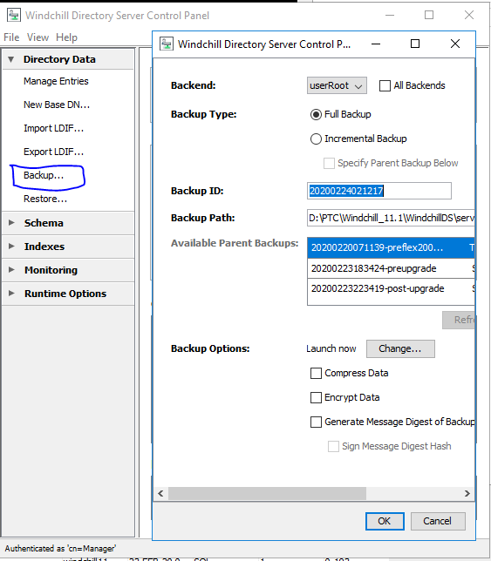

Directly import is not possible as both the target and source share same root, but the second level is different o=ptc, dn=Windchill_12.0 and o=ptc, dn=Windchill_11.1.

So do the following, the root.ldif exported is moved to target and copy the source as file ForUpgrade_12_0_and_11_1_together.ldif available, ran the following comment,go to the following path in Windchill Shell

<WindchillDS_Home>\server\bin and then ran

./export-ldif -n userRoot -D cn=Manager -w admin --appendToLDIF --ldifFile /appl/ptc/temp/windu_source_combined_target.ldif The resultant file has is a merged output of both source and target

Edit the file and remove second entry of

**dn: o=ptc**

**objectClass: top**

**objectClass: organization**

**o: ptc**

**createTimestamp: 20200213113835Z**

**creatorsName: cn=Directory Manager,cn=Root DNs,cn=config**

**entryUUID: 8aaec031-5797-427c-9c18-1c20a8494dcc**

import the resultant file

Once imported change the property in **com.agron.noc.Ldap**

 com.agron.noc.Ldap.java.naming.provider.url

In service com.agron.noc.Ldap

**Source** : com.agron.noc.Ldap.java.naming.provider.url=ldap://hq-flexqawc.noc.agron.com

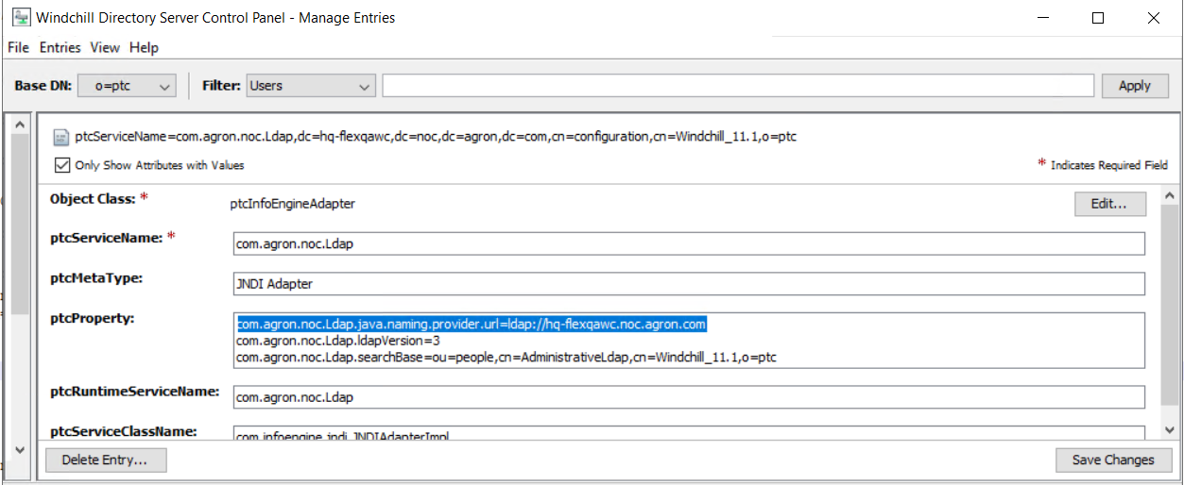

**Changed** : com.agron.noc.Ldap.java.naming.provider.url=ldap://hq-flexapp-k-dev.noc.agron.com:3899

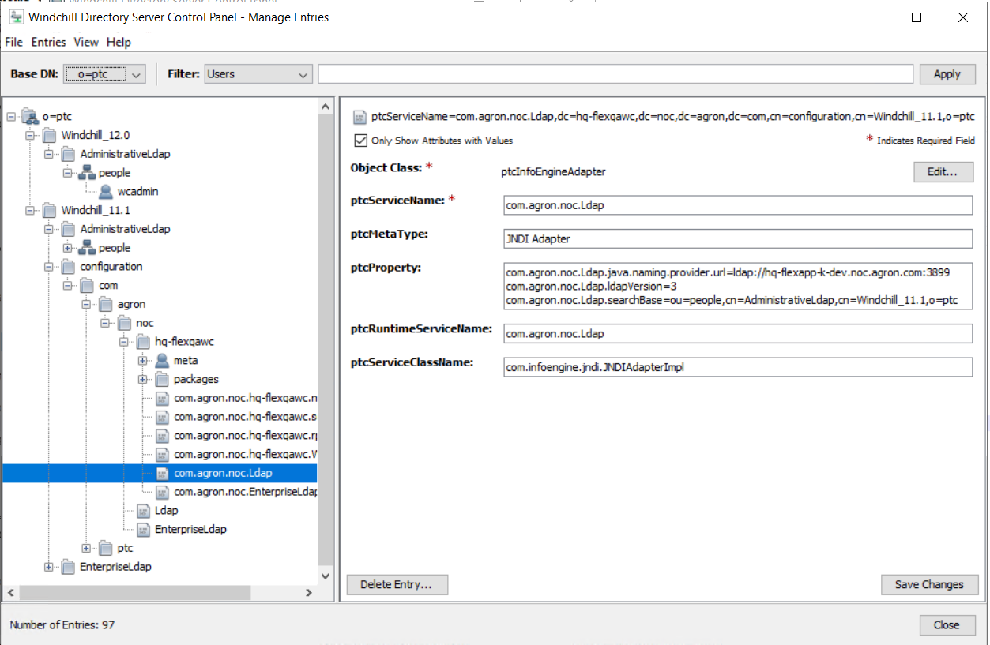

### **AddColumns utility**

* + 1. Copy the AddColumnsSchema.xml file from the source system to the target system. The file is located at the following path on the source system and must be copied to the same path on the target system: <Windchill>\conf\type\
    2. On the target system, open a Windchill shell.
    3. Run the following command: ./AddColumns.sh–deploy From WT_HOME/bin
    4. Refer <https://www.ptc.com/en/support/article/CS258541>

### **Custom Files to be updated**

Copy the all the folders under location /appl/ptc/Windchill_10.1/Windchill/wtCustom from source 10.1 server

To the same location in the target 11.0(/appl/ptc/Windchill_11.0/Windchill/wtCustom) & 11.2 (/appl/ptc/Windchill_11.2/Windchill/wtCustom) servers

Ran the following command from windchill shell

|  |
| --- |
| ant -f bin/tools.xml bundle_custom   ant -f codebase/MakeJar.xml custUpdate |

### **Cleanup of system if re-running upgrade manager(For failed upgrade system or reuse of same server for upgrade)**

Delete the following file:

<Windchill>/Upgrade/UpgradePhases/GatherUpgradeProperties/upgradeUser.properties

If using GatheredSourceUpgrade.properties, put a fresh copy from the source in place

### **Xconfmanager in target windchill shell**

|  |
| --- |
| xconfmanager -s "wt.queue.max.processQueues=1000" -t codebase/wt.properties -p  xconfmanager -t db/db.properties -s wt.pom.dbUser=c##newqa11 -p  xconfmanager -t db/db.properties -s wt.pom.dbPassword=newqa11 -p  xconfmanager -t codebase/wt.properties -s wt.audit.users.enabled=false -p  xconfmanager -t codebase/wt.properties -s wt.folder.updateFolderTimestamps=false -p  xconfmanager -s "wt.method.maxHeap=5120" -t codebase/wt.properties -p  xconfmanager -s "wt.method.minHeap=5120" -t codebase/wt.properties -p  xconfmanager -s "wt.method.bg.maxHeap=5120" -t codebase/wt.properties -p  xconfmanager -s "wt.method.bg.minHeap=5120" -t codebase/wt.properties -p  xconfmanager -s "wt.pom.queryLimit=250000" -t db/db.properties -p  xconfmanager -s "wt.pom.paging.snapshotQueryLimit=20000" -t db/db.properties -p  xconfmanager -s "wt.pom.maxDbConnections=50" -t db/db.properties -p  xconfmanager -t codebase/wt.properties -s com.ptc.windchill.upgrade.phases.upgradeschema.threadPoolSize=4 –p  xconfmanager -s "com.ptc.core.lwc.PrimeTypeCache=true" -t codebase/wt.properties -p xconfmanager -s "wt.cache.size.StructEnumAttTemplateCache=100" -t codebase/wt.properties -p xconfmanager -s "wt.cache.size.EnumerationDefinitionCache=1602" -t codebase/wt.properties -p xconfmanager -s "wt.cache.size.TypeDefinitionCache2=1694" -t codebase/wt.properties -p xconfmanager -s "wt.cache.size.PropertyDefinitionCache=1032" -t codebase/wt.properties -p xconfmanager -s "wt.cache.size.IBADefViewManager$IBADefViewCache=446" -t codebase/wt.properties -p xconfmanager -s "wt.cache.size.ClassificationEnumCache=1000" -t codebase/wt.properties -p |

### **Update for vaults**

|  |
| --- |
| UPDATE fvmount SET PATH = REPLACE(PATH,'\\HQ-FLEXDEVFILE\vaultqa11\','\\HQ-FLEXDEVFILE\vaultqa12\')  WHERE local=1  UPDATE fvmount SET PATH = REPLACE(PATH,'D:\ptc\Windchill_11.1\','D:\ptc\Windchill_12.0\\')  WHERE local=0  update rootmount set PATH='D:\ptc\Windchill_12.0\Windchill\vaults\defaultuploadrootfolder' Where PATH='D:\ptc\Windchill_11.1\Windchill\vaults\defaultuploadrootfolder'  UPDATE rootmount SET PATH = REPLACE(PATH,'D:\ptc\Windchill_11.1\','D:\ptc\Windchill_12.0\')  UPDATE rootmount SET PATH = REPLACE(PATH,'\\HQ-FLEXDEVFILE\vaultqa11','\\HQ-FLEXDEVFILE\vaultqa12') |

### **Custom Files to be updated**

Copy the all the folders under location /appl/ptc/Windchill_10.1/Windchill/wtCustom from source 10.1 server

To the same location in the target 11.0(/appl/ptc/Windchill_11.0/Windchill/wtCustom) & 11.2 (/appl/ptc/Windchill_11.2/Windchill/wtCustom) servers

Ran the following command from windchill shell

|  |
| --- |
| ant -f bin/tools.xml bundle_custom   ant -f codebase/MakeJar.xml custUpdate |

## Running upgrade Manager

From VNC Session start the upgrade manager

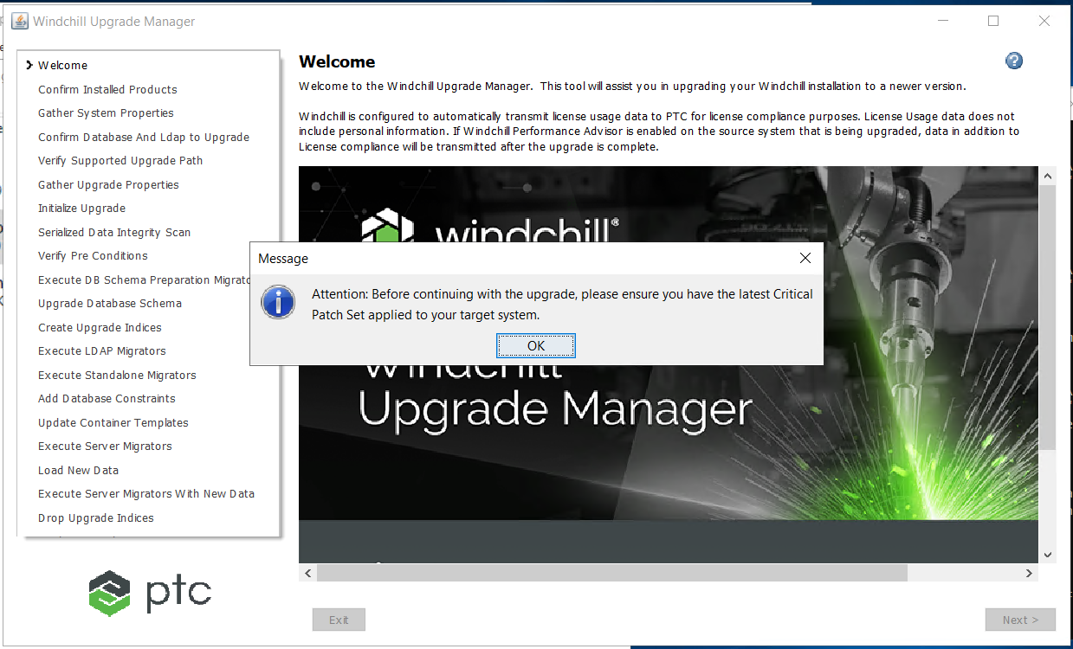

Click ok

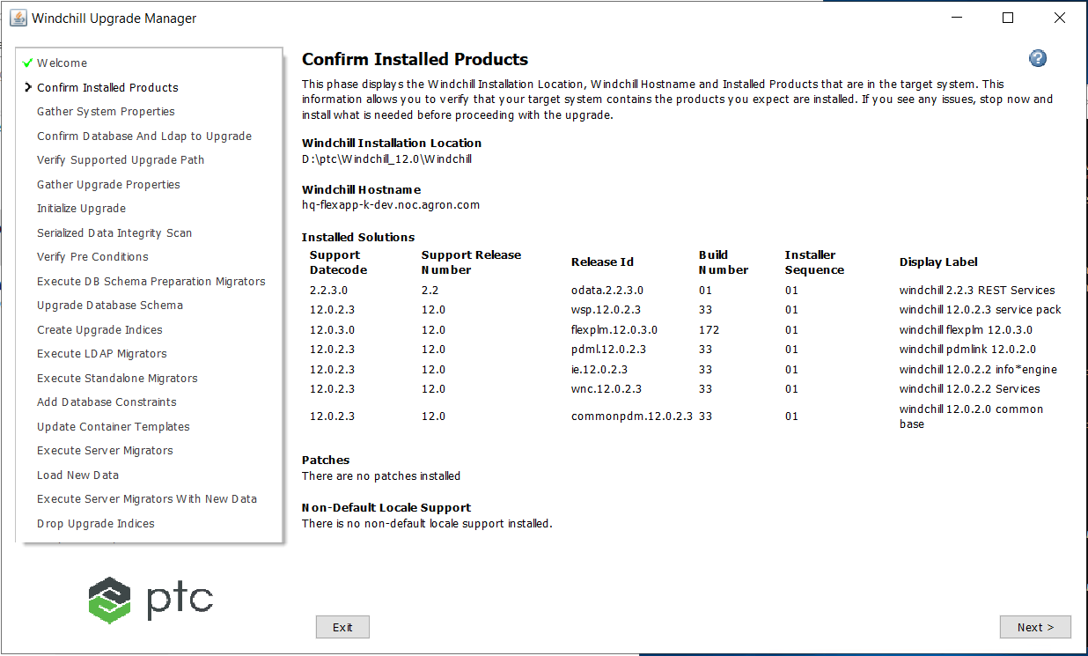

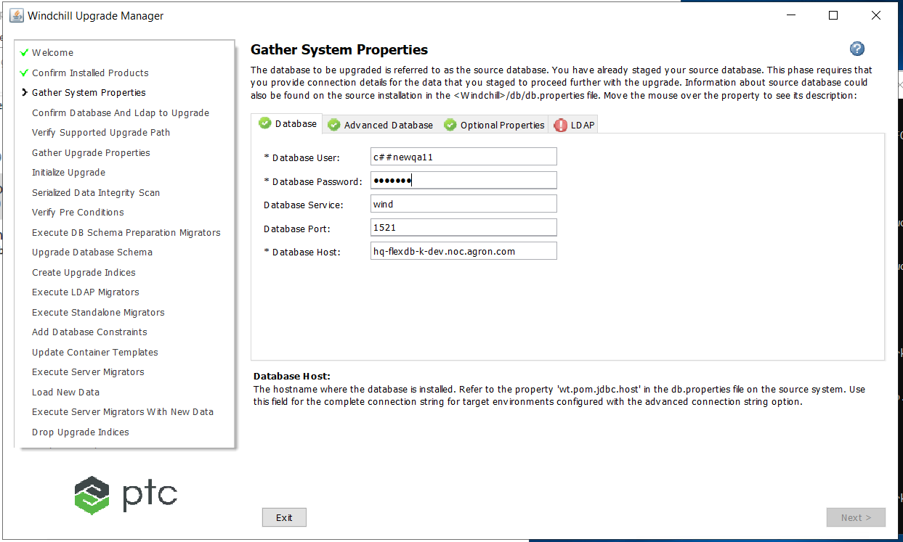

Database user : imported database user id

Password : db password

DB service : wind.noc.agron.com

DB port : 1521& DB host: system host for database

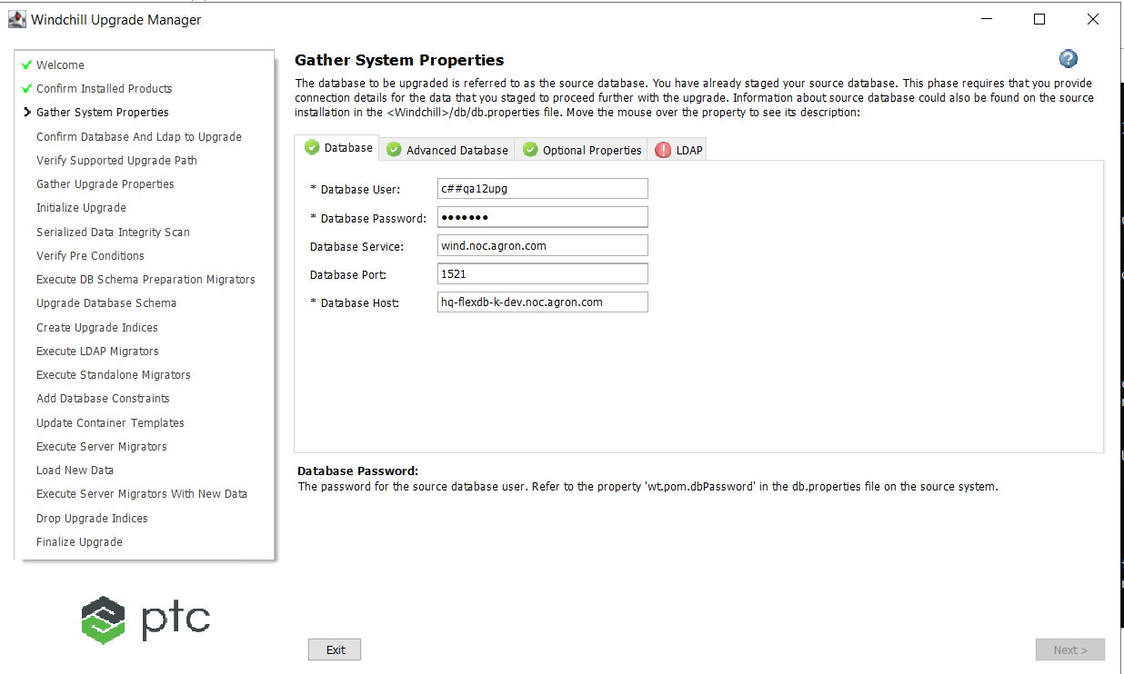

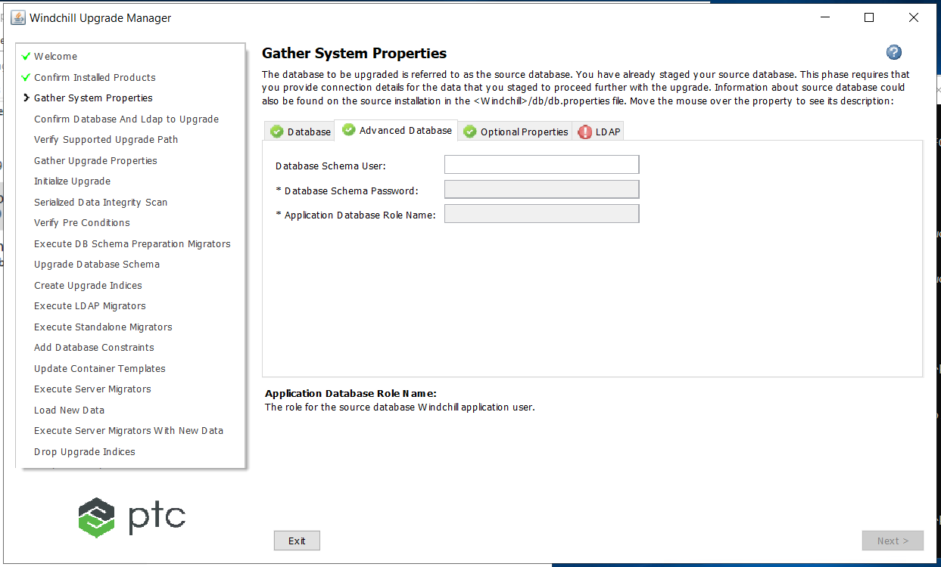

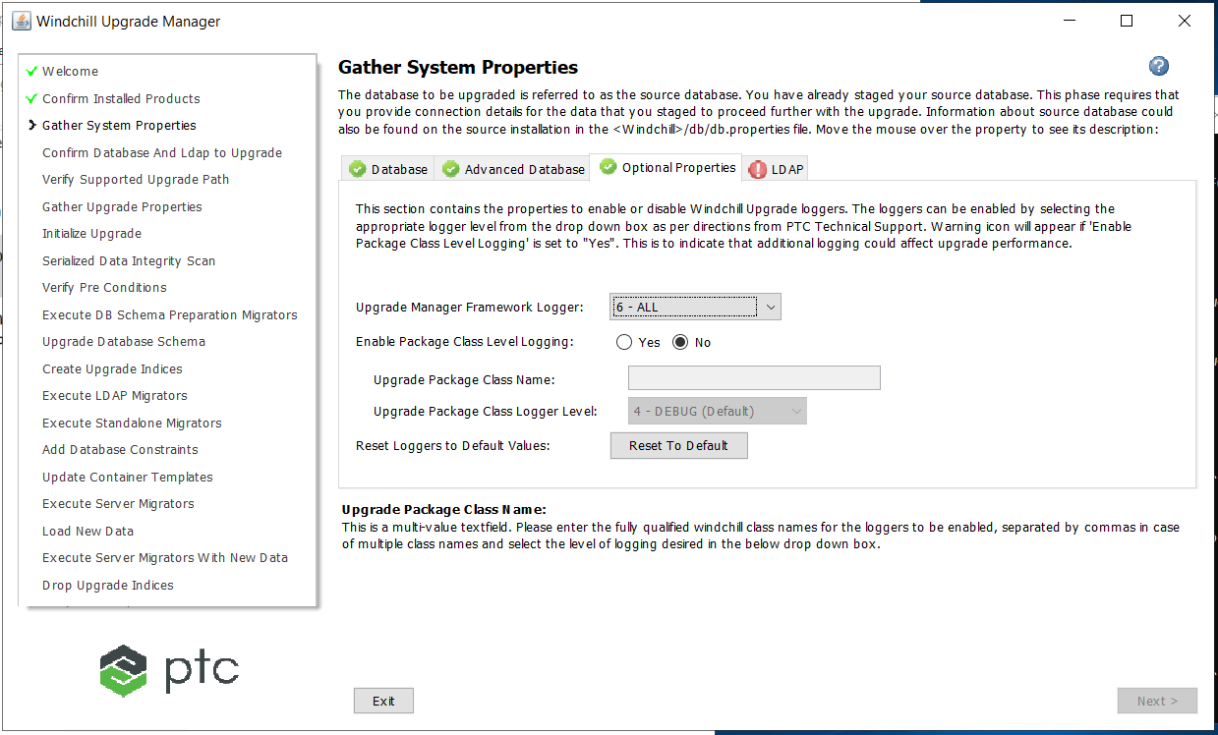

Upgrade Manager Framework Logger : 6 - ALL

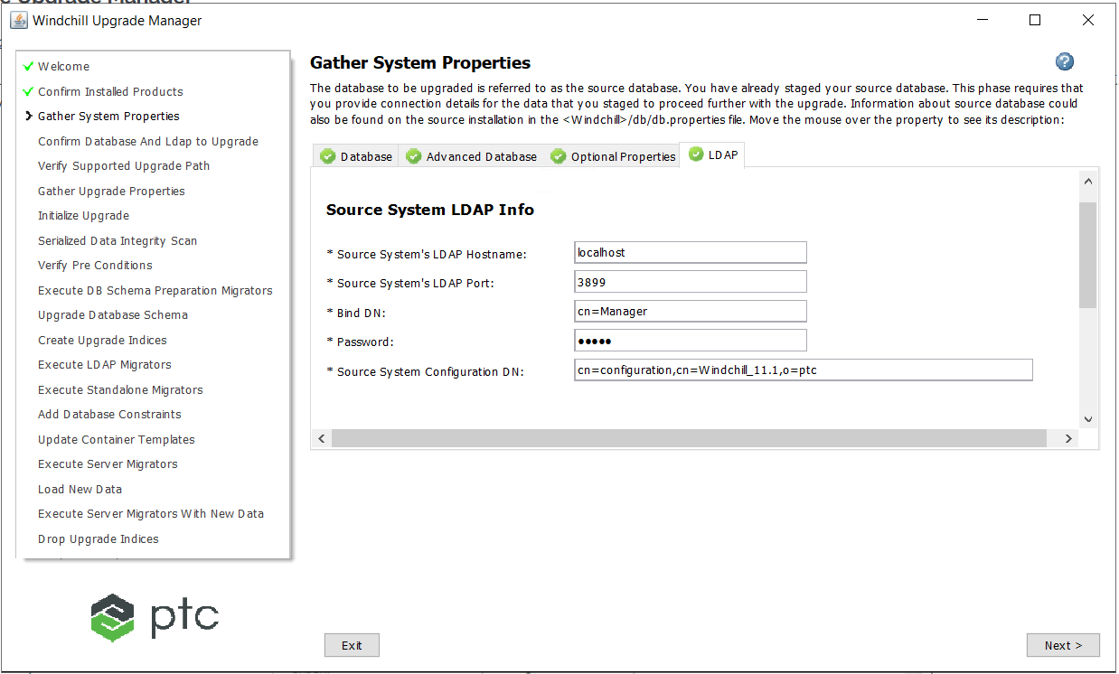

Refer section 1.1.6

Source systems LDAP HostName : localhost/hq-flexapp-k-dev

Source systems LDAP port : 3899

Bind DN : cn=Manager

Password : admin

Source System Configuration DN: cn=configuration, cn=Windchill_11.1,o=ptc

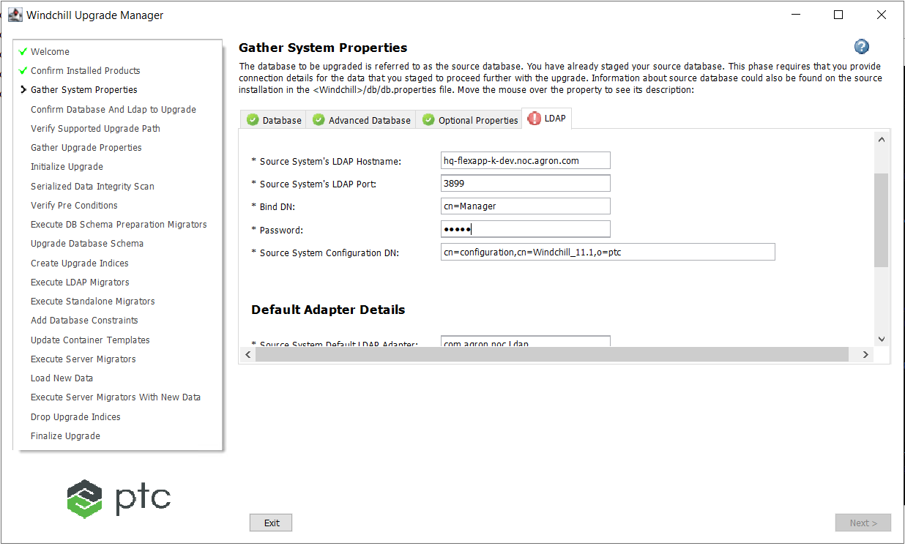

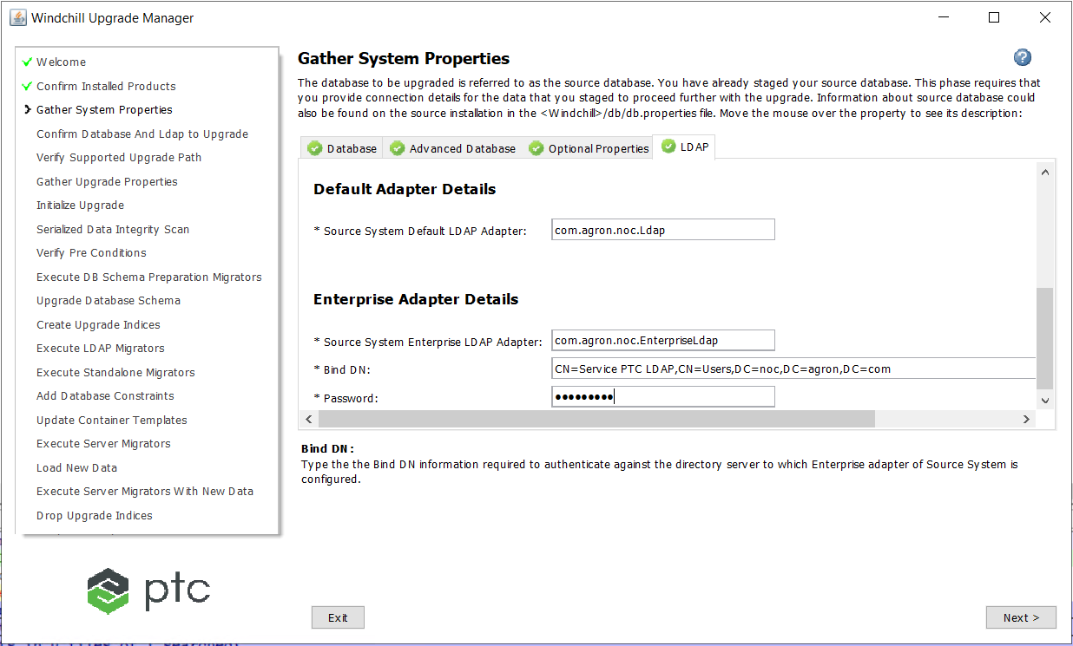

Source System Default Adapter:com.agron.noc.LDAP

Source System Enterprise LDAP Adapter: com.agron.noc.EnterpriseLdap

Bind Dn: cn=Service PTC LDAP, cn=Users, DC=noc, DC=agron, DC=com

Password: LD4P4dm!n

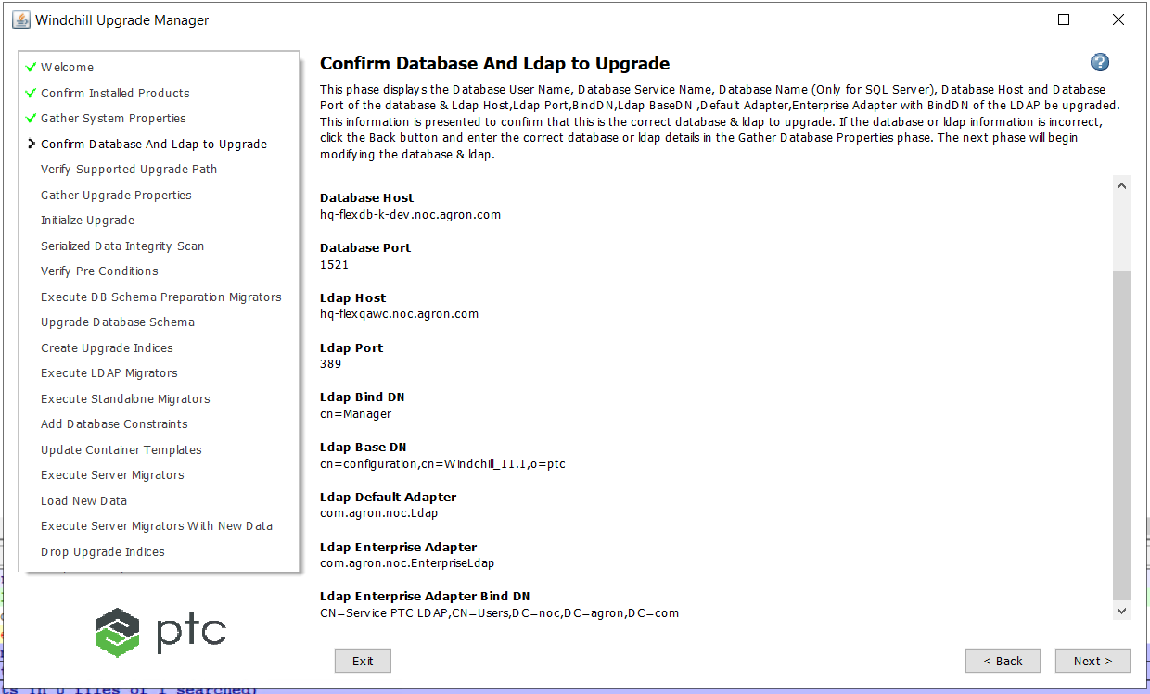

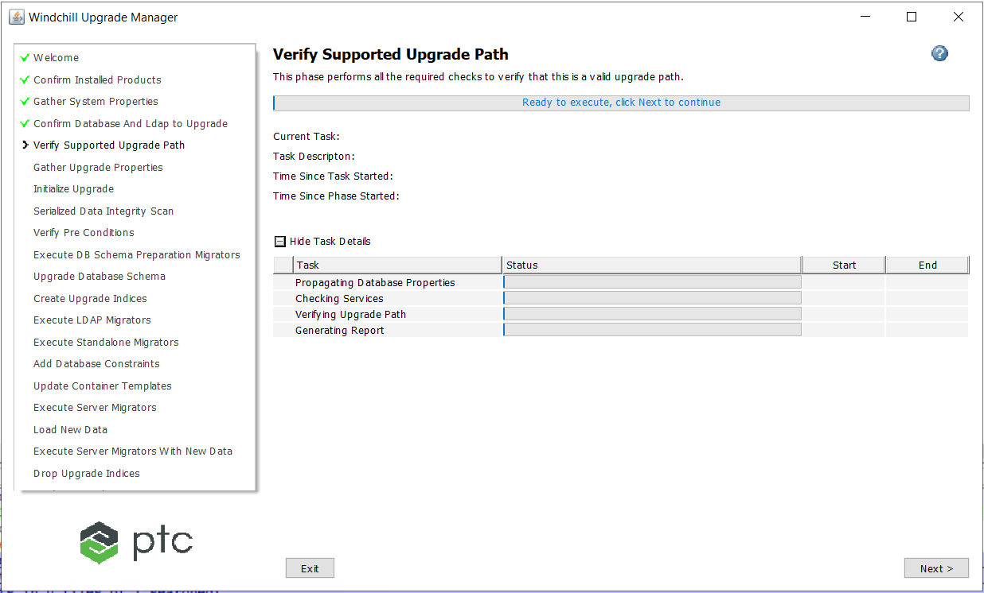

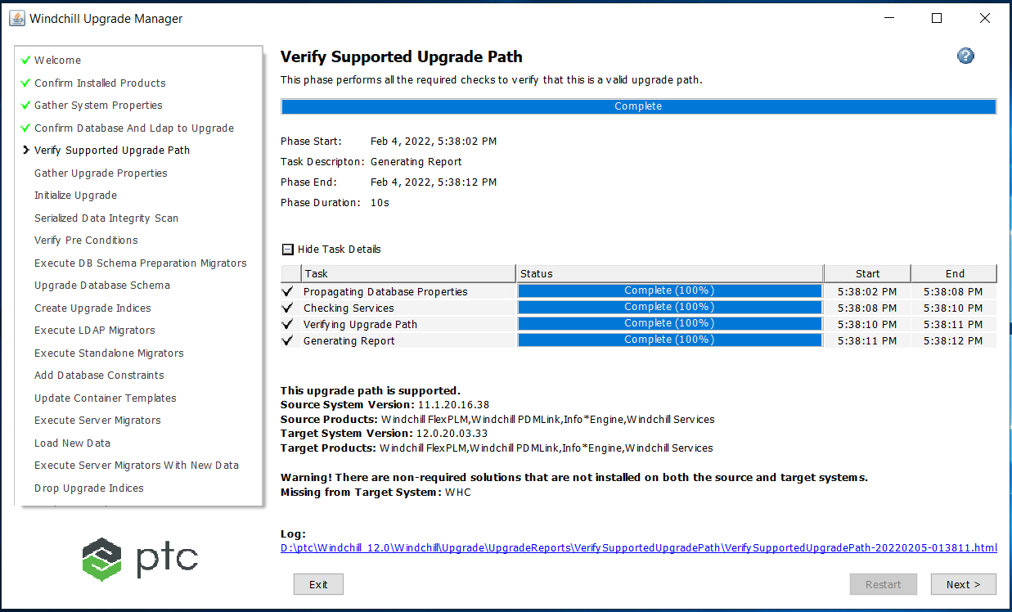

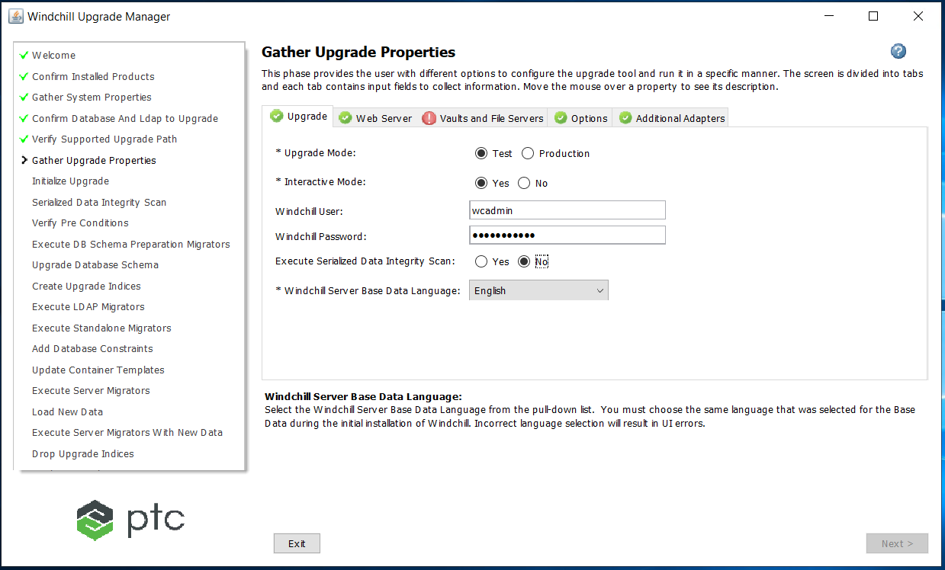

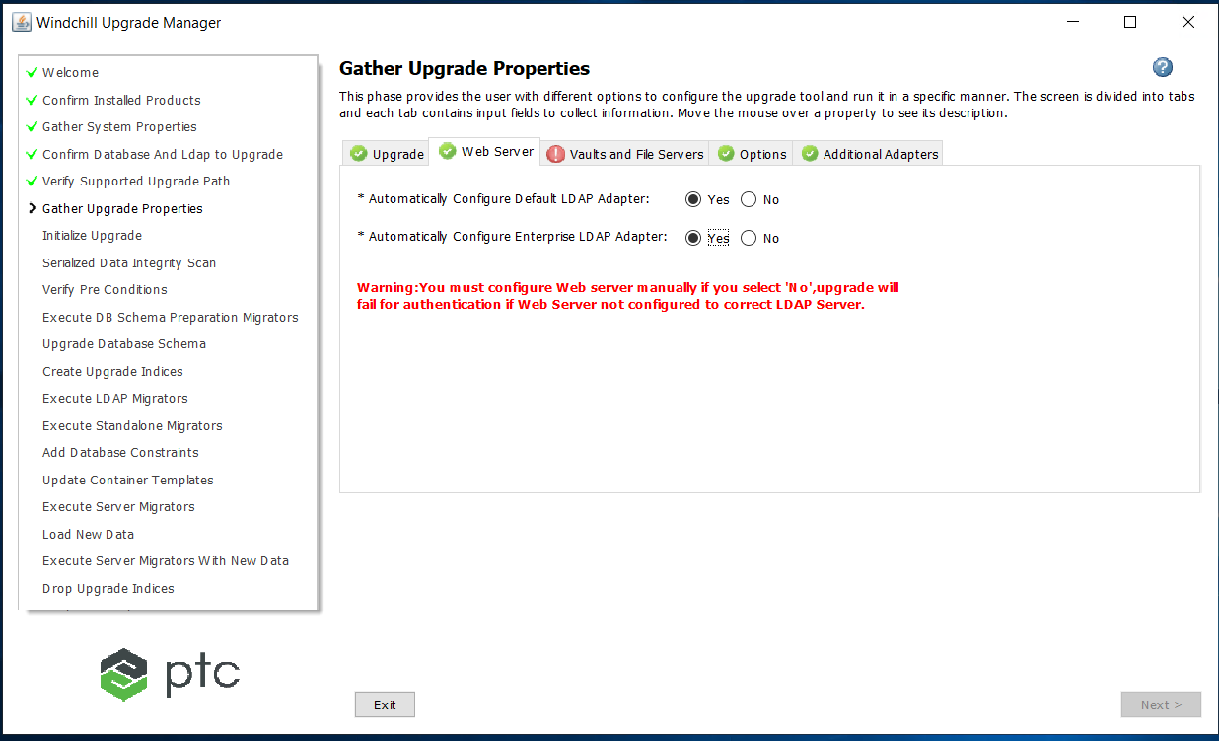

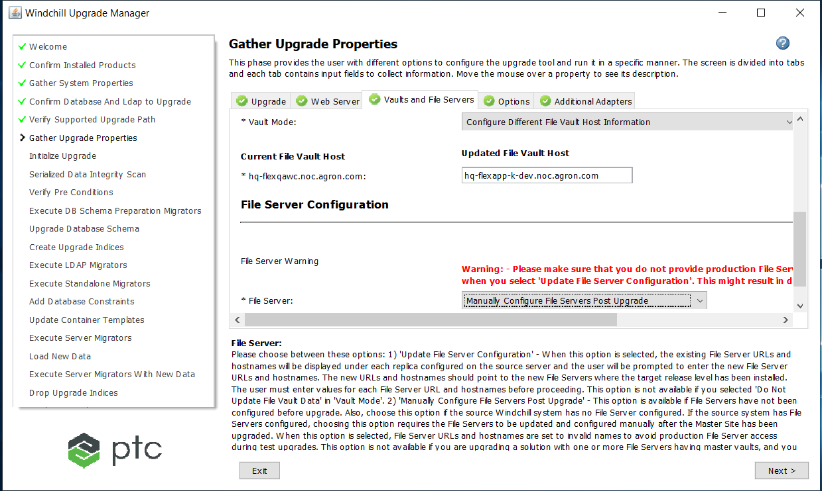

Updated file vault host: hq-flexapp-k-dev.noc.agron.com

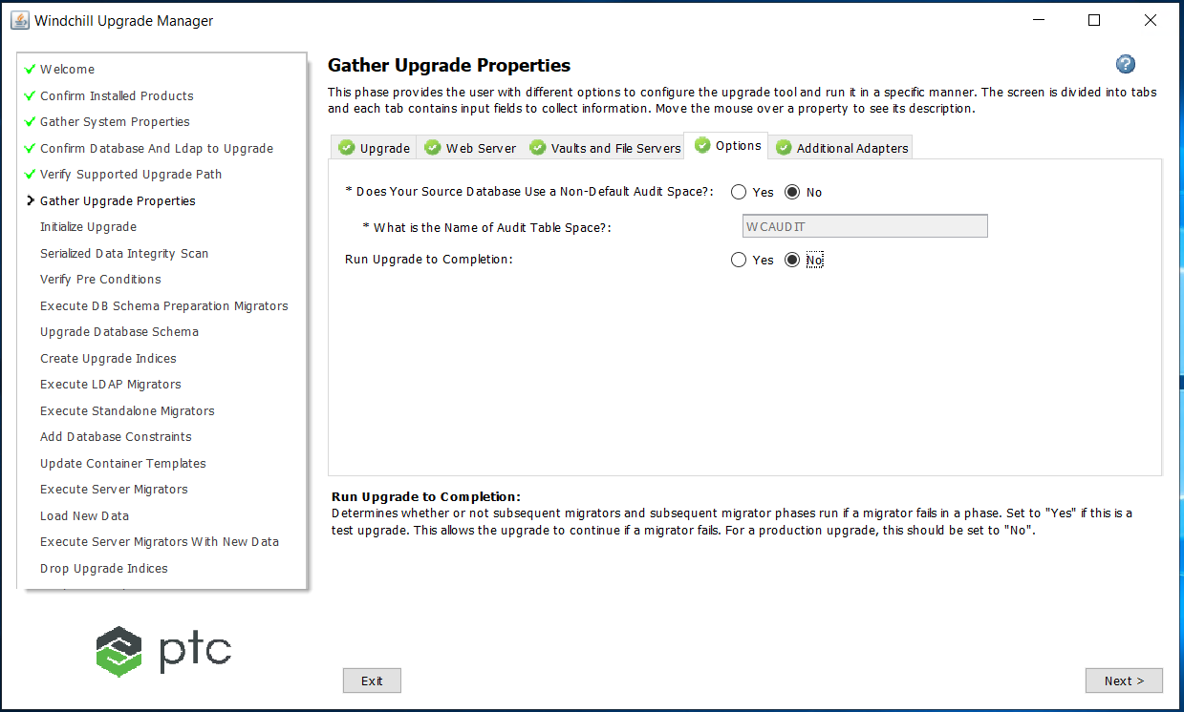

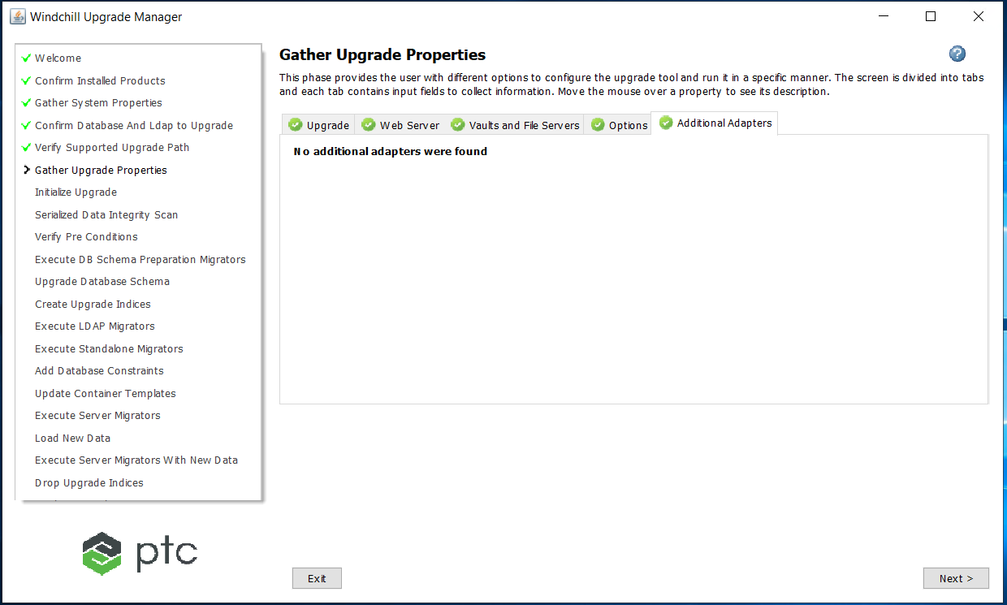

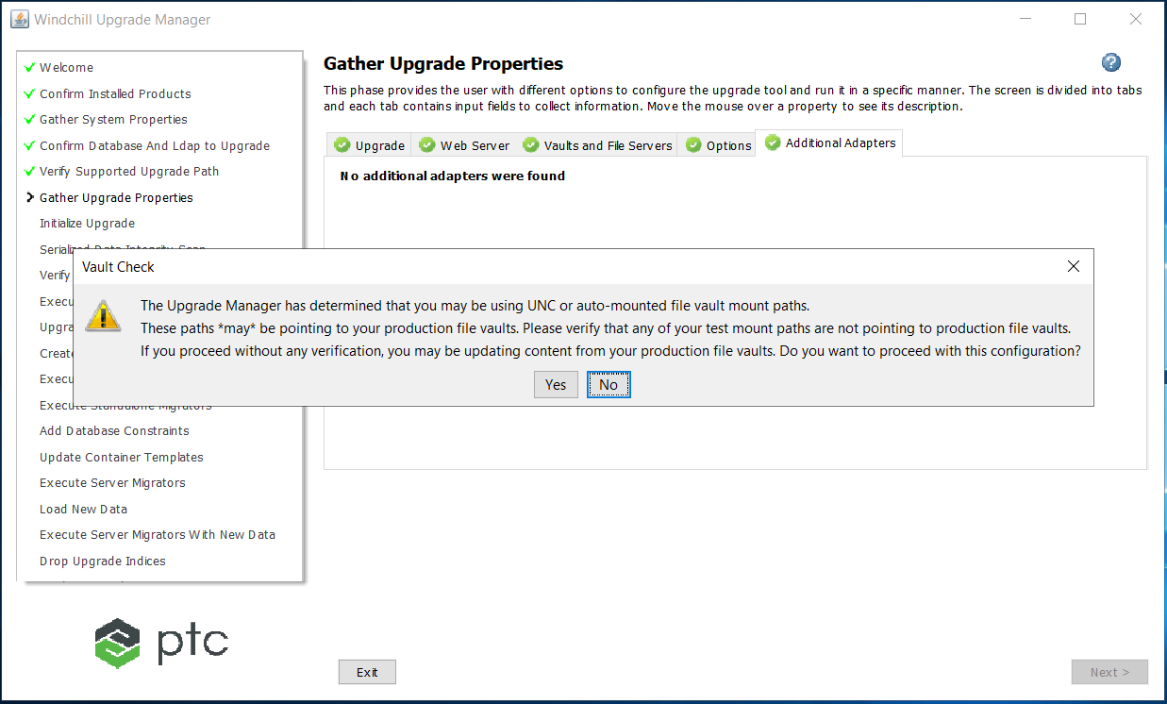

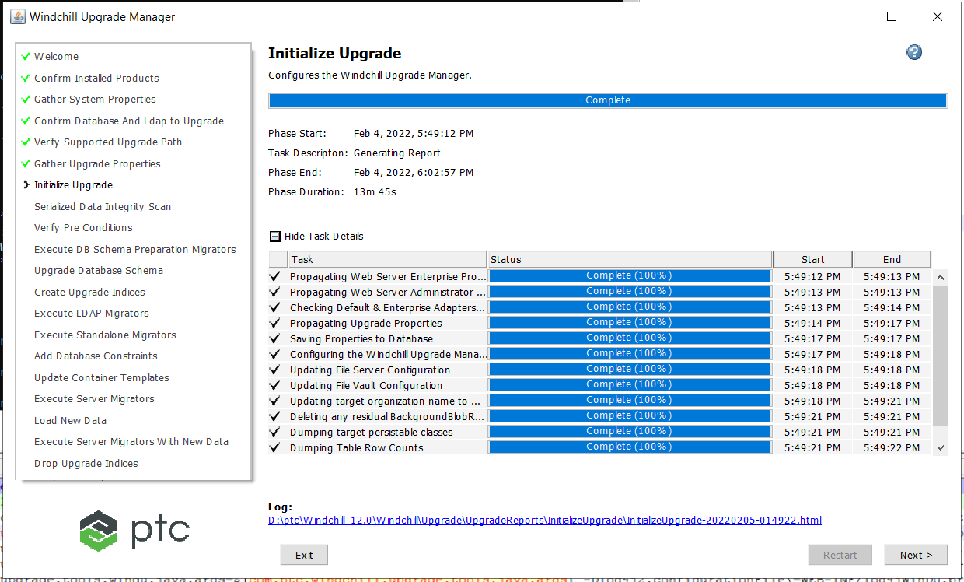

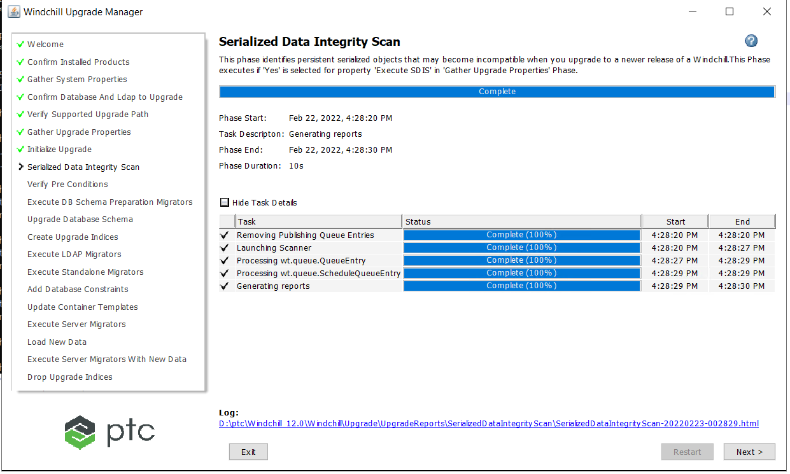

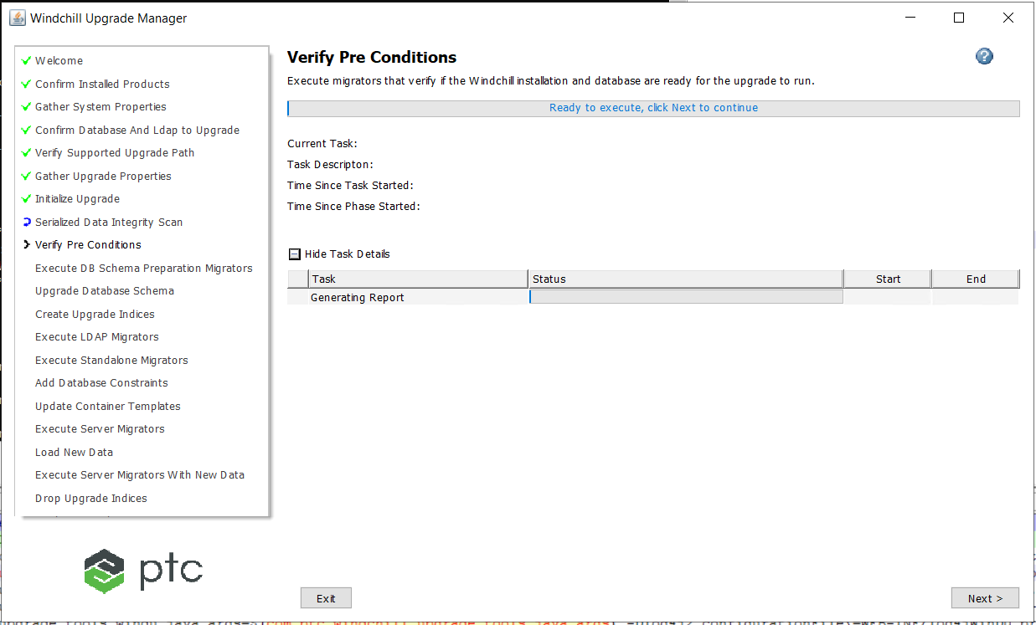

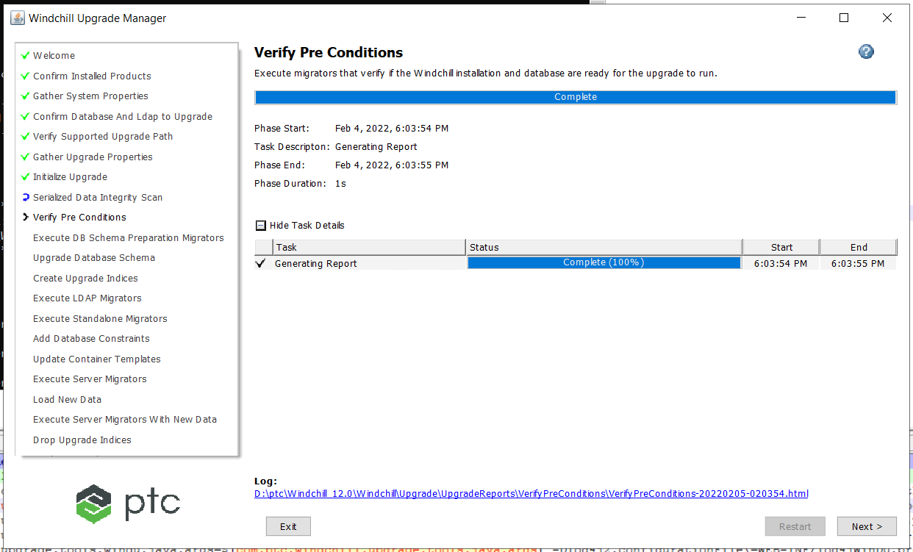

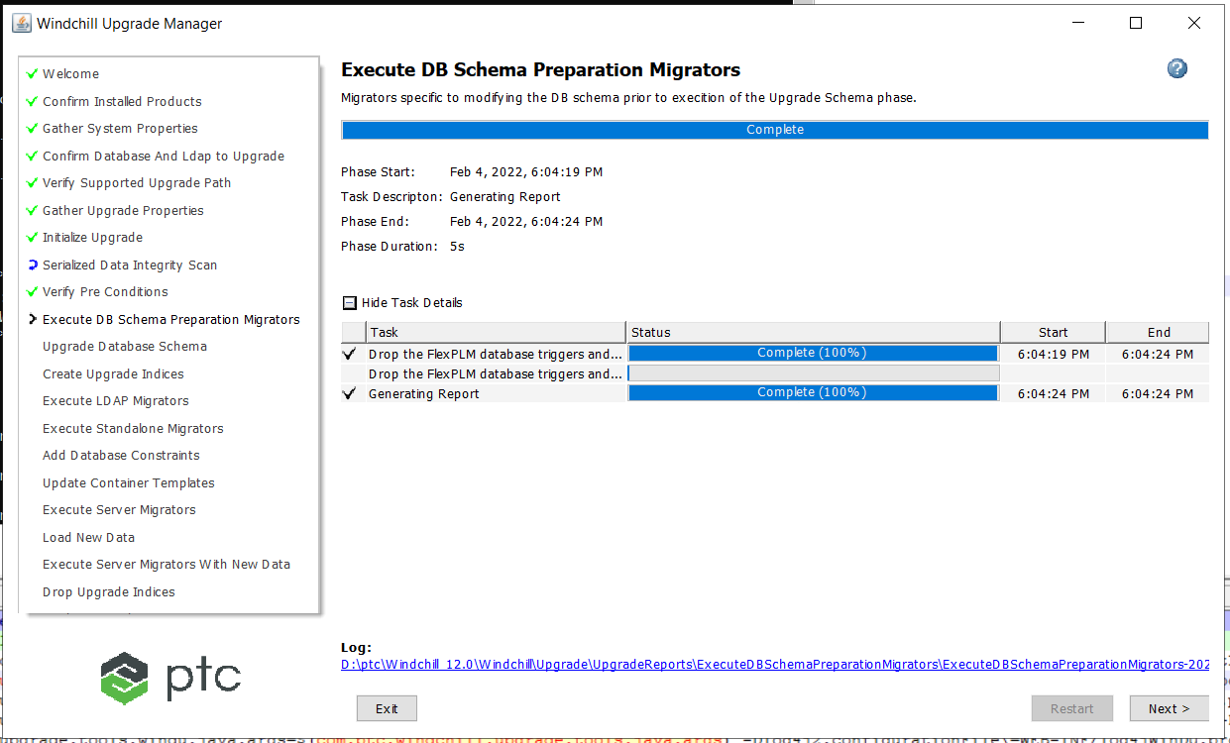

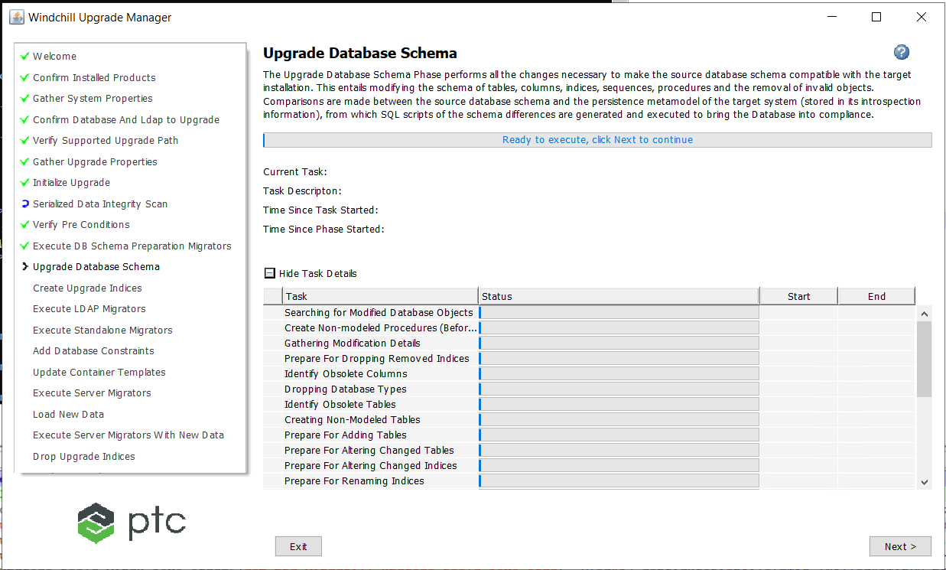

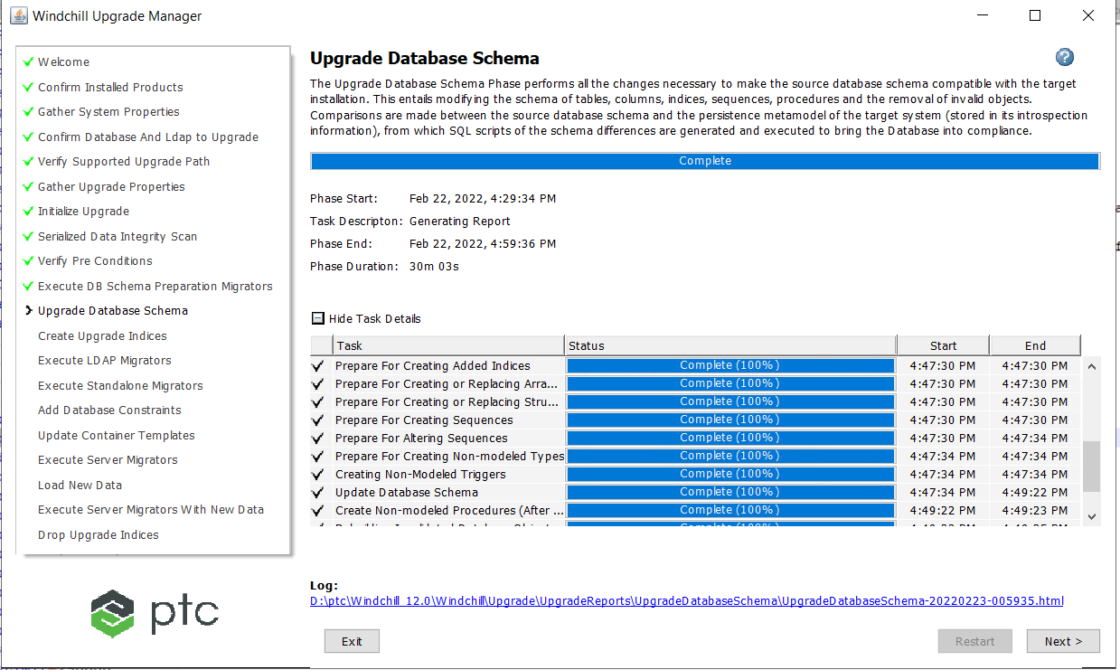

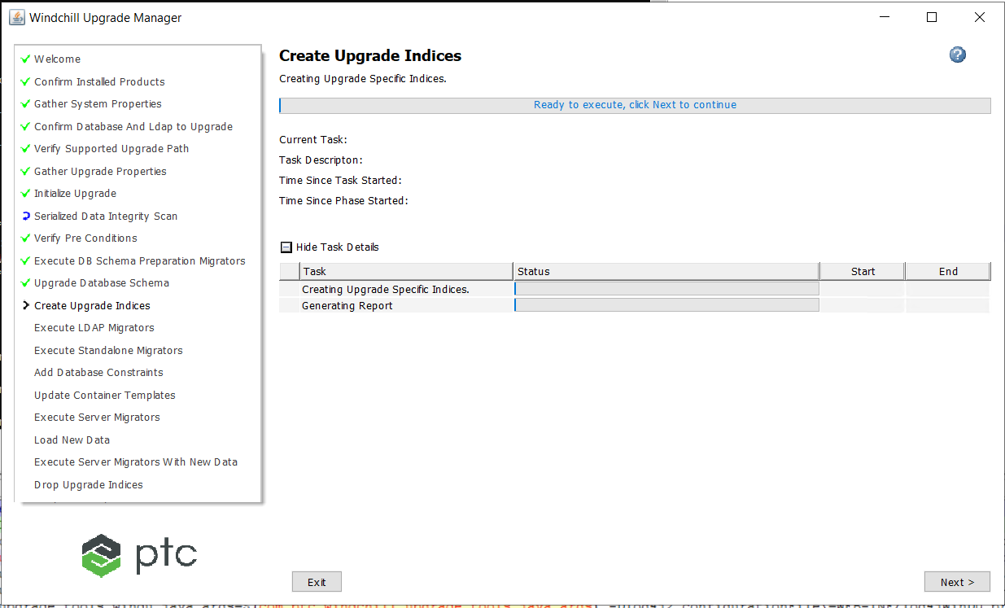

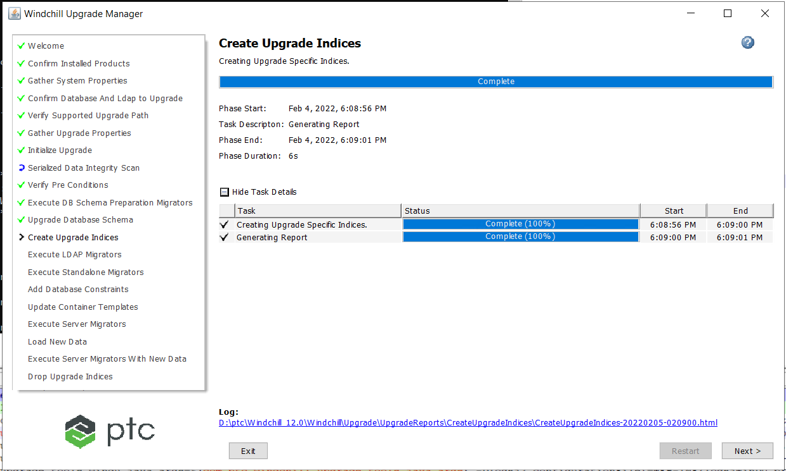

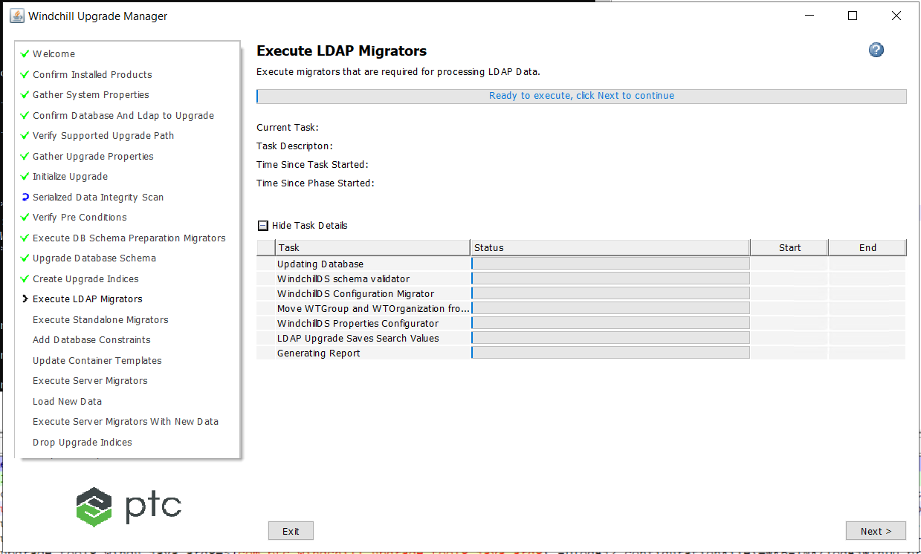

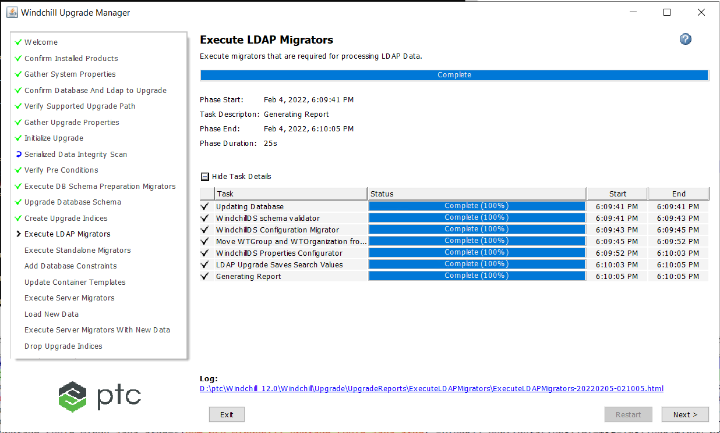

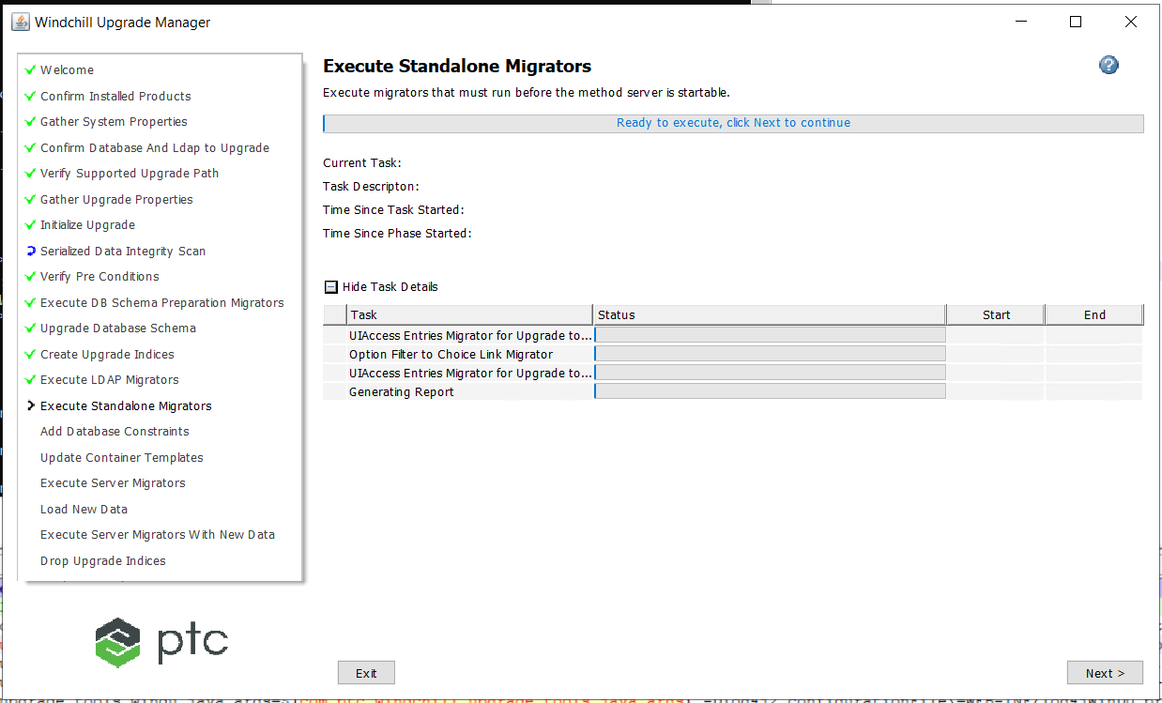

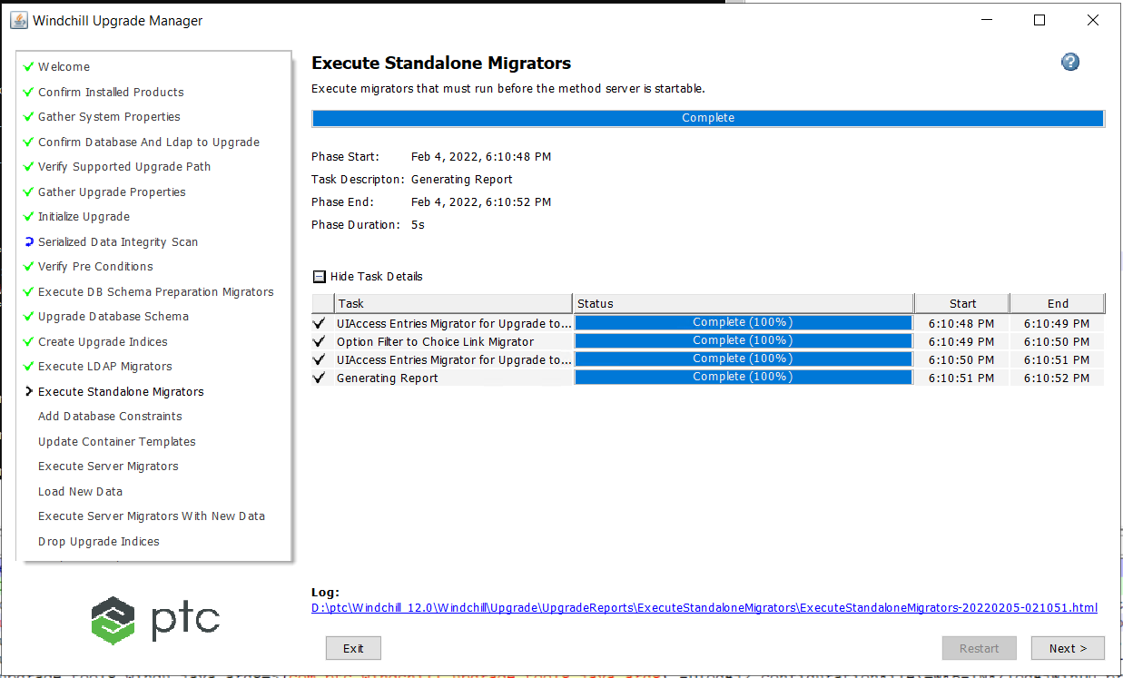

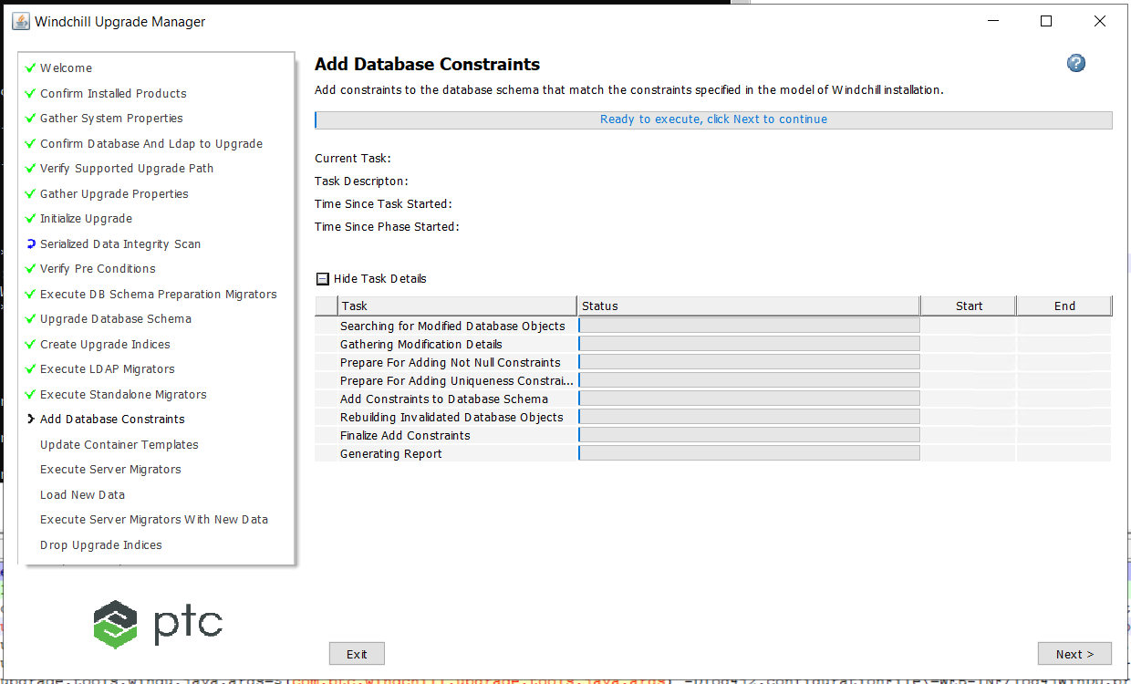

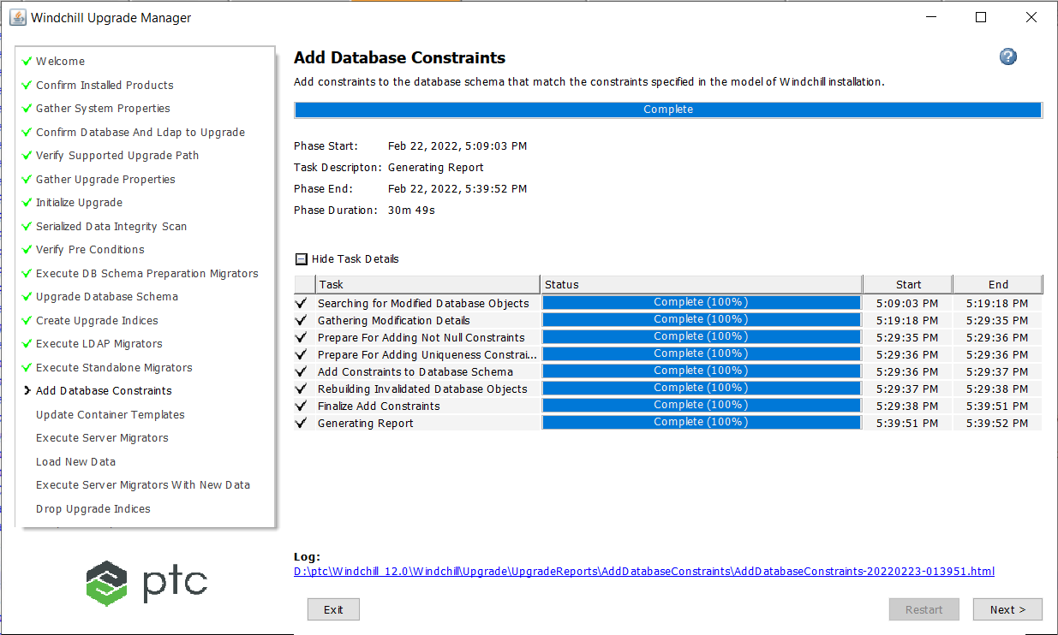

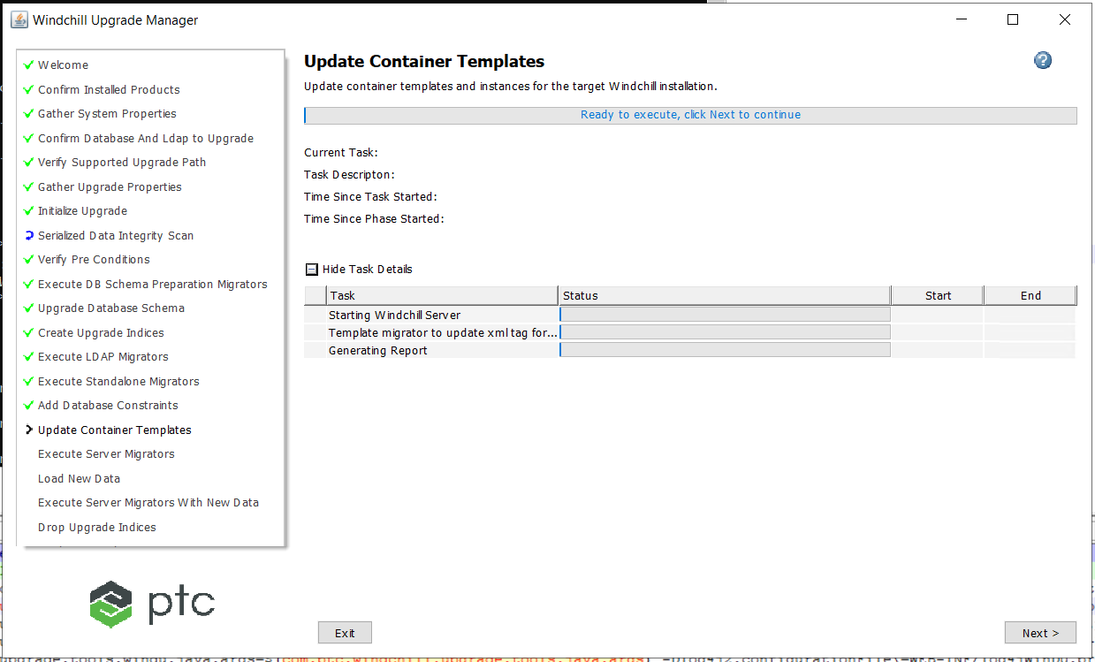

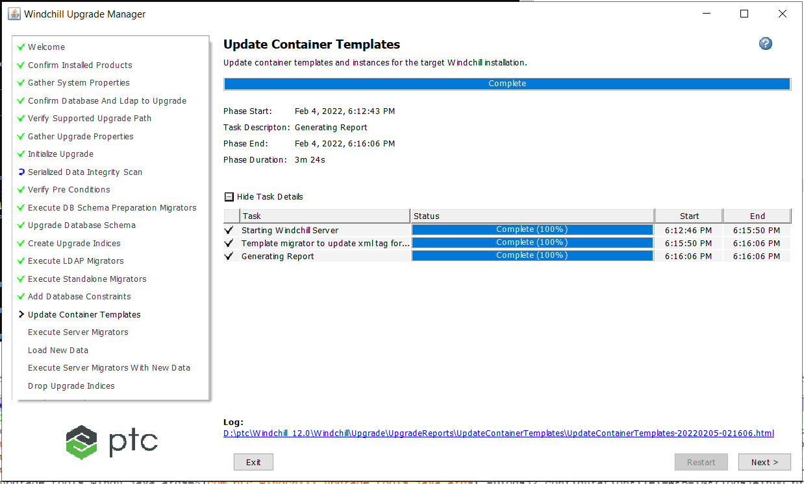

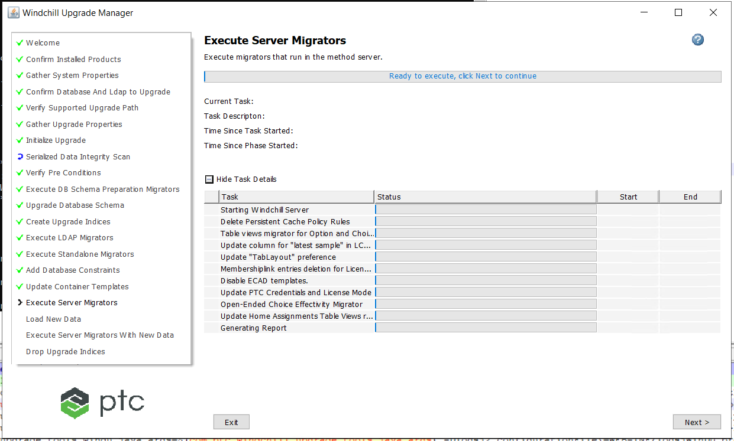

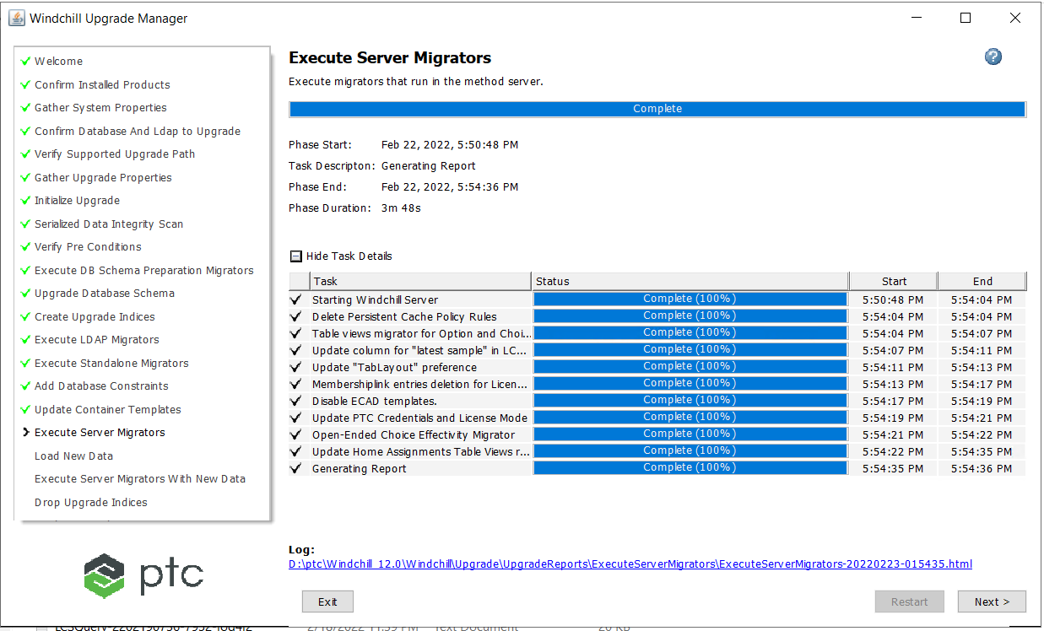

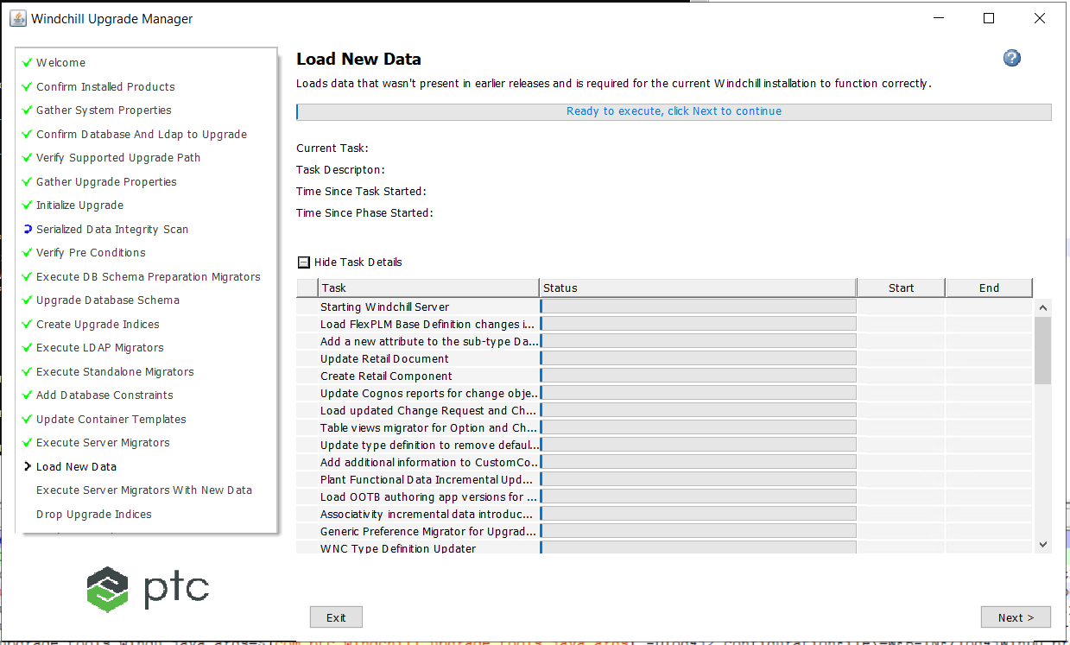

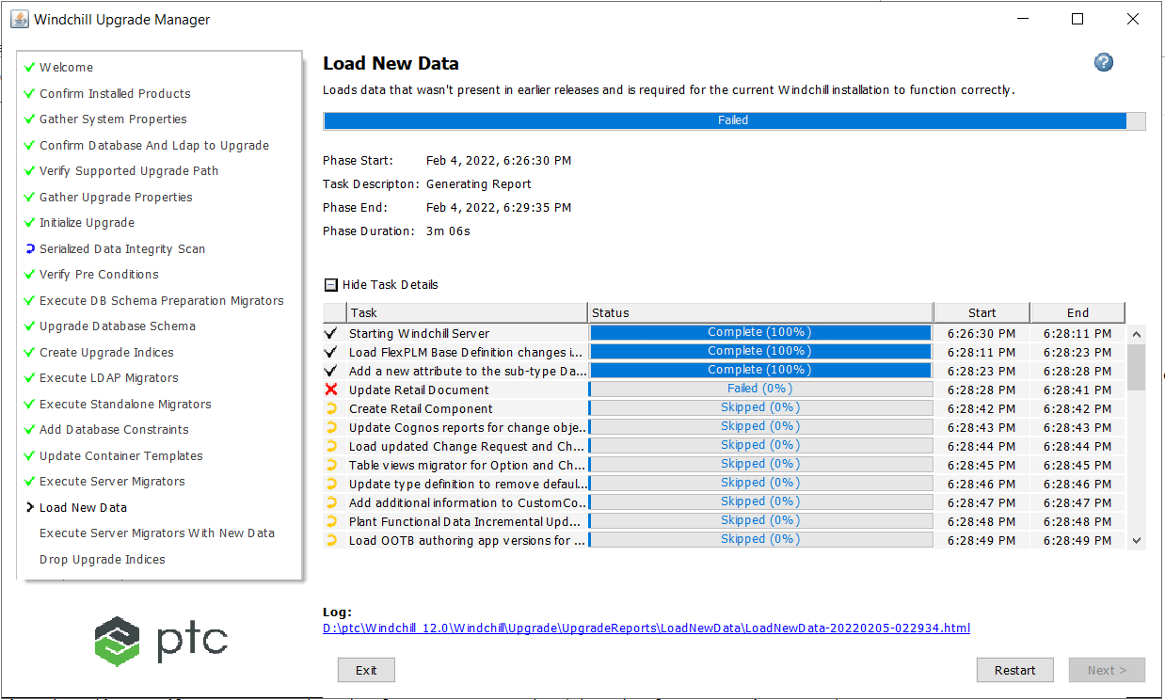

Error is

2022-02-05 02:28:41,473 INFO [RMI TCP Connection(5)-10.0.0.124] wt.system.outwcadmin - Create Rule </Default/RFA,com.agron.VisualAsset,Participant: ALL,-,0,null>

2022-02-05 02:28:41,477 INFO [RMI TCP Connection(5)-10.0.0.124] wt.system.outwcadmin - com.agron.VisualAsset type is invalid

2022-02-05 02:28:41,478 INFO [RMI TCP Connection(5)-10.0.0.124] wt.system.outwcadmin - Loader method wt.load.LoadUser.createAccessRule reported a failure

2022-02-05 02:28:41,480 INFO [RMI TCP Connection(5)-10.0.0.124] wt.system.errwcadmin - (wt.ixb.handlers.netmarkets.NMIxResources/108) wt.util.WTException: Loader method wt.load.LoadUser.createAccessRule reported a failure

2022-02-05 02:28:41,480 INFO [RMI TCP Connection(5)-10.0.0.124] wt.system.errwcadmin - at wt.ixb.handlers.netmarkets.CsvIxHandler.handleError(CsvIxHandler.java:131)

2022-02-05 02:28:41,480 INFO [RMI TCP Connection(5)-10.0.0.124] wt.system.errwcadmin - at wt.ixb.handlers.netmarkets.CsvIxHandler.createObject(CsvIxHandler.java:246)

2022-02-05 02:28:41,481 INFO [RMI TCP Connection(5)-10.0.0.124] wt.system.errwcadmin - at wt.ixb.actor.PickingExistingObjectActorForPersistable.createObject(PickingExistingObjectActorForPersistable.java:34)

2022-02-05 02:28:41,481 INFO [RMI TCP Connection(5)-10.0.0.124] wt.system.errwcadmin - at wt.ixb.actor.ActorTemplateForPersistable._createObject(ActorTemplateForPersistable.java:340)

2022-02-05 02:28:41,481 INFO [RMI TCP Connection(5)-10.0.0.124] wt.system.errwcadmin - at wt.ixb.publicforhandlers.ClassExporterImporterTemplate.createObjects(ClassExporterImporterTemplate.java:784)

2022-02-05 02:28:41,481 INFO [RMI TCP Connection(5)-10.0.0.124] wt.system.errwcadmin - at wt.ixb.publicforhandlers.ClassExporterImporterTemplate.importElementsBatchDefault(ClassExporterImporterTemplate.java:672)

Refer

<https://www.ptc.com/en/support/article/cs350345>

Edit

D:\PTC\Windchill_12.0\Windchill\loadXMLFiles\RFA\RFAProdAccessRules.xml

Comment out all the NmLoader entries

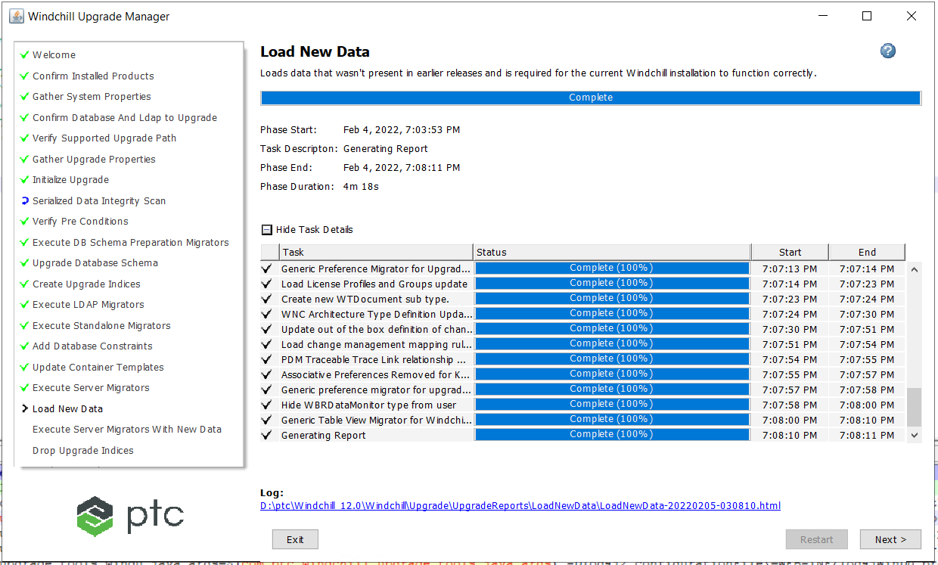

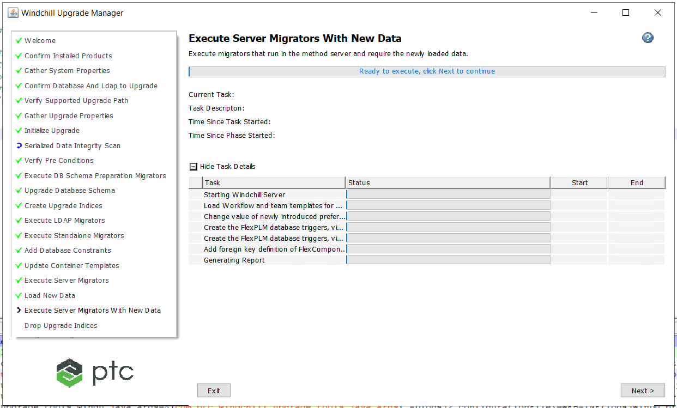

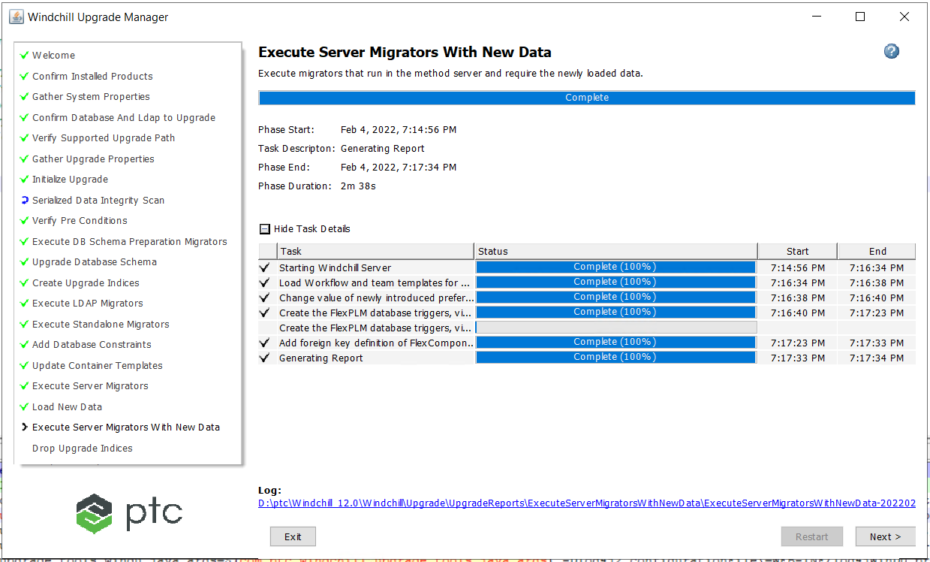

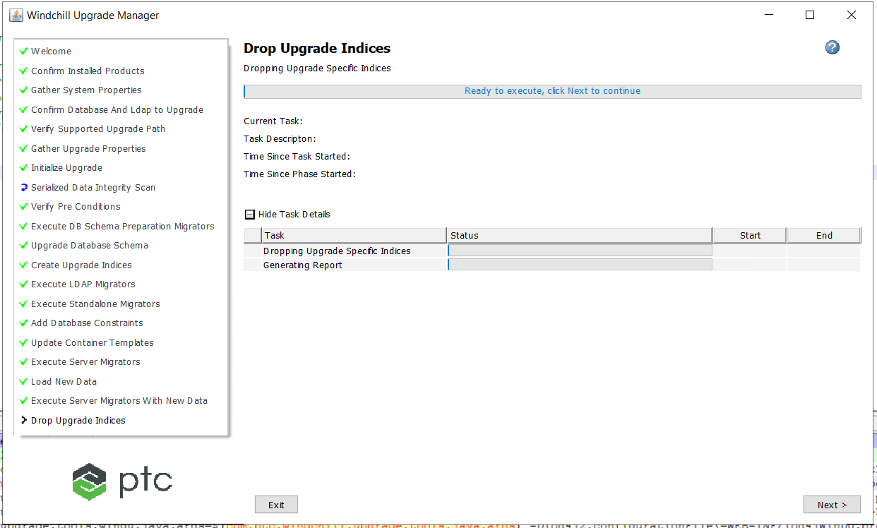

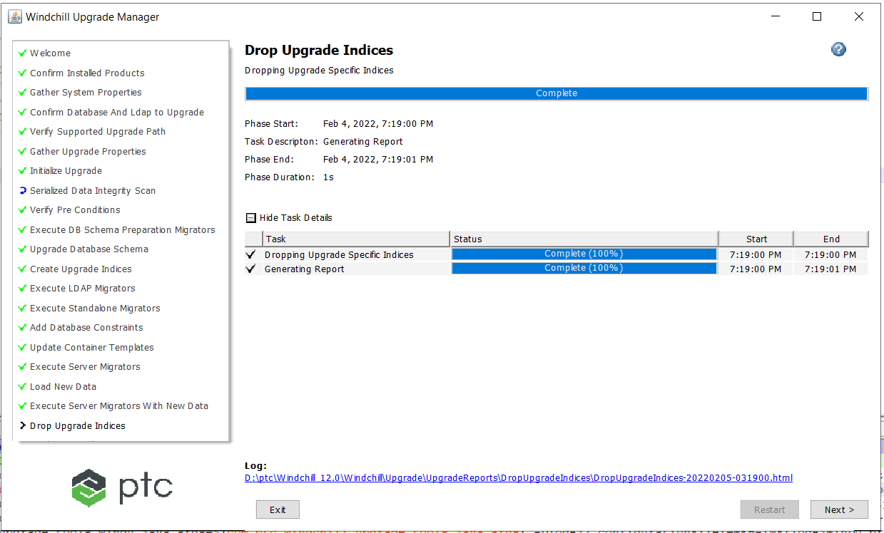

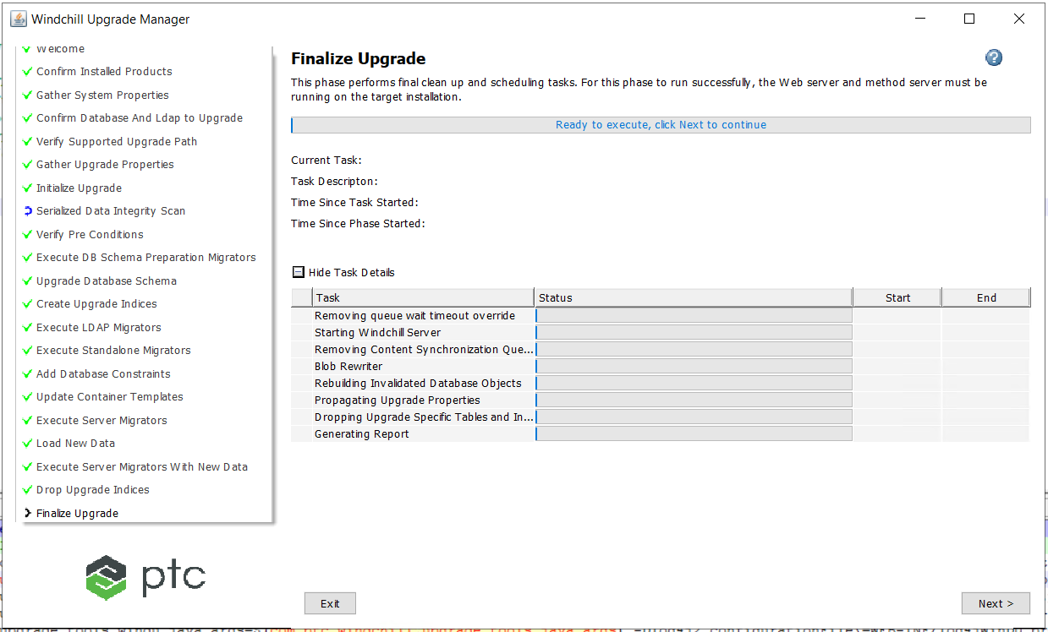

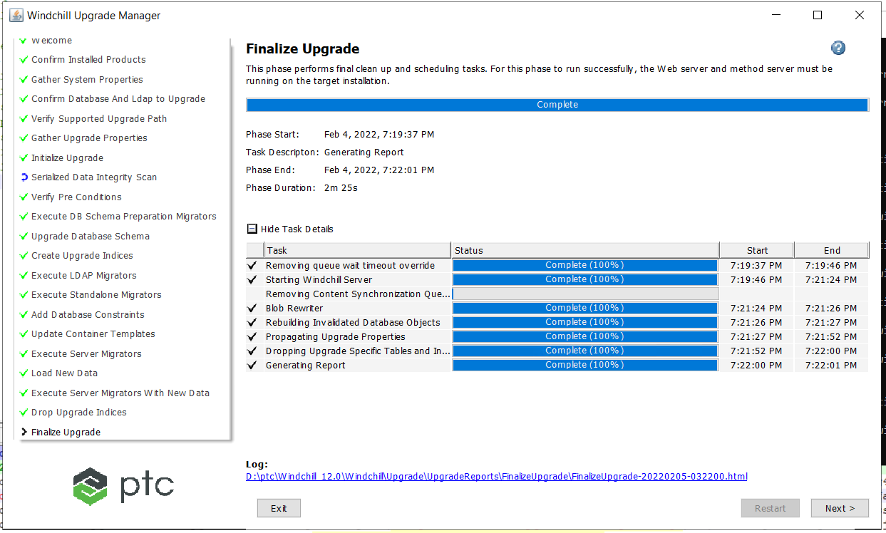

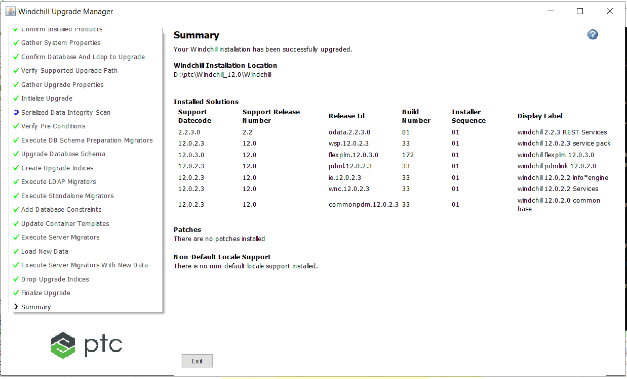

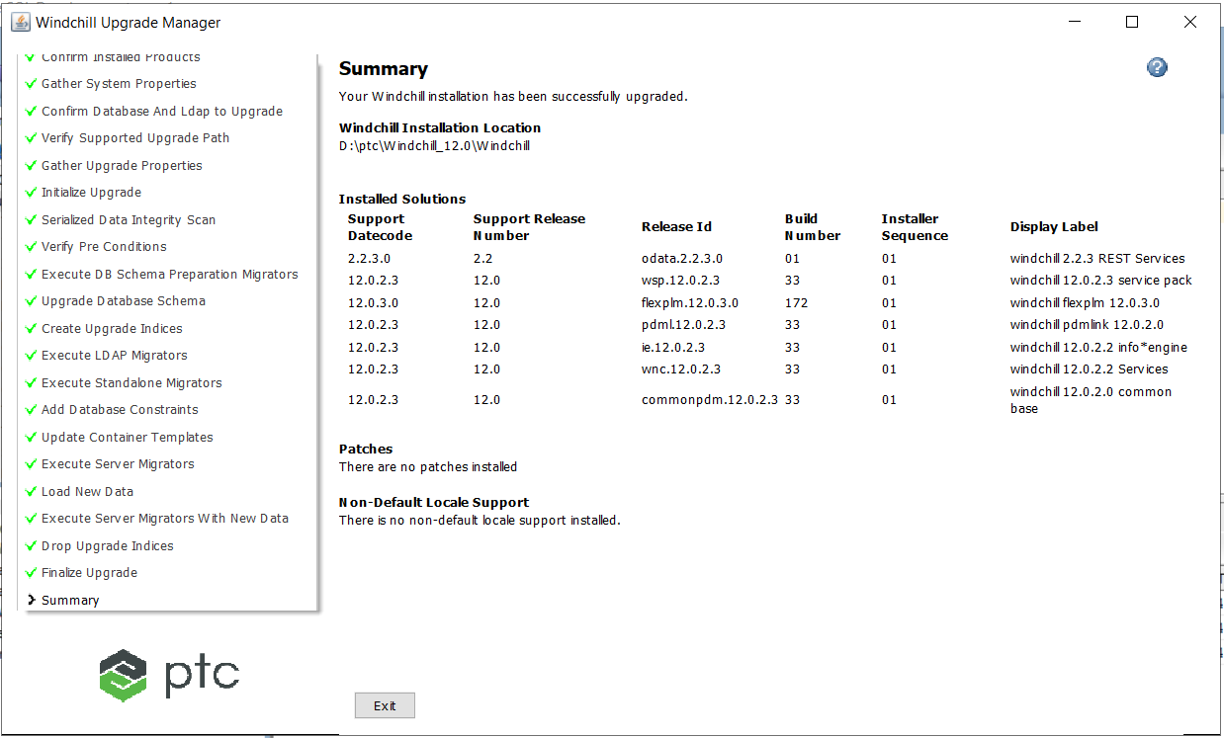

## Post Upgrade Steps

### **Apache Setting changes**

Change 40-app-RFA-FHC.conf with below addition of Windchill-EnterpriseLdap

So that users from AD can use Flex Help center

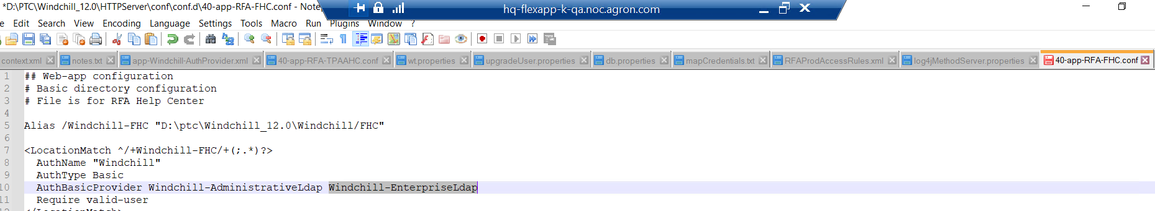

### **Validate all mounts**

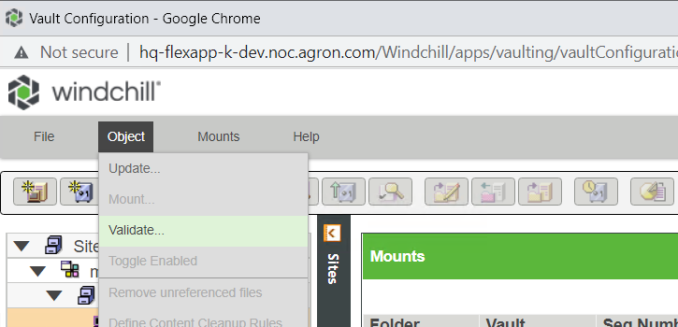

### **Move from WindchillDS to OpenDJ**

From ldap window Manage entries Delete the following

|  |
| --- |
| cn=configuration,cn=Windchill_11.1,o=ptc  cn=EnterpriseLdap,cn=Windchill_11.1,o=ptc  cn=Windchill_12.0,o=ptc |

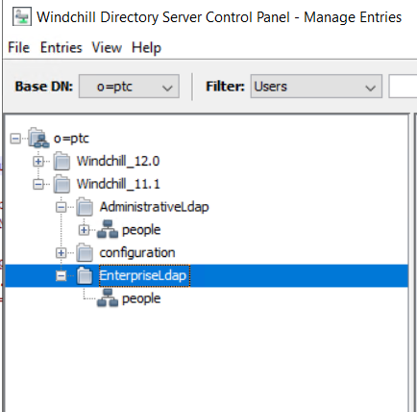 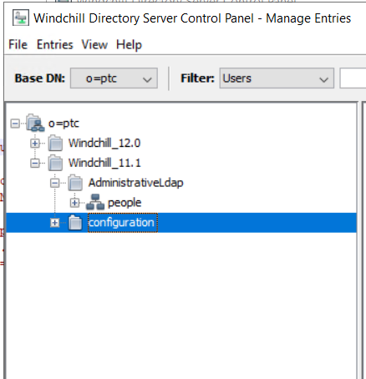

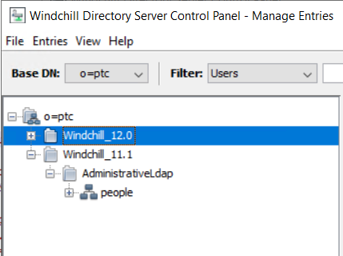

Leave only ou=people,cn=AdministrativeLdap,cn=Windchill_11.1,o=ptc node

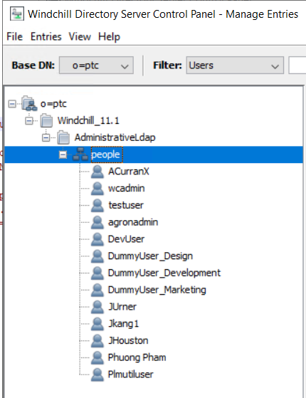

Restart the windchill to check everything works fine as before.

If everything works fine export the ldif do the below modification to ldif file

|  |
| --- |
| Replace "objectClass: ptcSubtree" with "objectClass: organizationalRole". |

OpenDJ Control-panel and import the ldif file modified above.

Ran the below command in Windchill Shell

|  |
| --- |
| xconfmanager -s "wt.federation.ie.ldapServer=ldap://hq-flexapp-k-qa.noc.agron.com:389" -t codebase/wt.properties -p  xconfmanager --undefine "mapcredentials.admin.adapters" –p  xconfmanager -s "mapcredentials.admin.adapters=com.agron.noc.Ldap^cn=Directory Manager^admin" -t "codebase/WEB-INF/mapCredentials.txt" –p  xconfmanager --add "mapcredentials.admin.adapters=com.agron.noc.EnterpriseLdap^CN=Service PTC LDAP,CN=Users,DC=noc,DC=agron,DC=com^LD4P4dm!n" -t "codebase/WEB-INF/mapCredentials.txt" -p |

From HTTPServer home ran the below command

|  |
| --- |
| ant -f webAppConfig.xml addAuthProvider -DappName=Windchill -DproviderName=AdministrativeLdap -DldapUrl="ldap://hq-flexapp-k-qa.noc.agron.com:389/ou=people,cn=AdministrativeLdap,cn=Windchill_11.1,o=ptc" -DbindDn="CN=Directory Manager" -DbindPwd=admin |

in WTHome\IEConf\adapterservice.json change the below text

|  |
| --- |
| "com.agron.noc.Ldap.java.naming.provider.url=ldap://hq-flexapp-k-dev.noc.agron.com:3899",  To  "**com.agron.noc.Ldap.java.naming.provider.url=ldap://hq-flexapp-k-qa.noc.agron.com:389**", |

Restart Windchill and check everything works fine

### **Log4J update**

Add the below lines to log4jMethodServer.properties in WTHome/codebase/WEB-INF/

|  |
| --- |
| #  # Refer https://www.ptc.com/en/support/article/cs282233  logger.AttributeDefinitionViewFactory.name=com.ptc.core.lwc.server.cache.factory.AttributeDefinitionViewFactory  logger.AttributeDefinitionViewFactory.level=FATAL |